officedown template

Your Name

2024-08-15

# Introduction

Vertical stacking of species is an emblematic signature of biologically rich regions and is associated with patterns of species richness from local to global scales (MacArthur 1958; MacArthur and MacArthur 1961; Oliveira and Scheffers 2019; Basham et al. 2023). At local scales, species assemblages may be stratified across vertical resource and climate gradients from beneath the ground to the top of the canopy (Basham et al. 2023; Xing et al. 2023). Tall, multi-layered forests with high foliage height diversity increase both the volume of habitat and the niche opportunities within the habitat, acting effectively as multi-floored apartments that enable species to vertically partition resources (R. Macarthur and Levins 1967; MacArthur and MacArthur 1961; LaRue et al. 2023). By reducing competition, vertical stratification may thus act as a mechanistic link to positive relationships between canopy height and species richness (Culbert et al. 2013; Feng et al. 2020; Gillespie and Walter 2001; Wagner et al. 2023). *concept fig* This hypothesis has been supported by positive relationships between verticality, defined here as the average vertical position of species in an assemblage, and species richness (Oliveira and Scheffers 2019). However, canopy height and other metrics of vegetation structure do not consistently impact species richness at regional to global scales, with notable declines in the strength of the relationship at higher latitudes where the diversity of arboreal species generally declines (LaRue et al. 2023; Roll, Geffen, and Yom-Tov 2015; Oliveira and Scheffers 2019). Examining the impacts of climatic and vegetative drivers of vertical stratification may thus add nuance to our understanding of the impact of canopy height on species richness.

At regional to global scales, climate may constrain vertical stratification in some regions despite the presence of tall forests. Vertical climate gradients are characterized by fossorial and terrestrial habitats that exhibit lower thermal variability and greater moisture availability than arboreal habitats, which are exposed to hotter maximum temperatures, colder minimum temperatures, and lower humidity (Scheffers and Williams 2018; Leahy et al. 2021; De Frenne et al. 2019). In high latitude forests, low minimum temperatures in the canopy may exceed physiological thresholds and constrain species to lower vertical positions (Oliveira and Scheffers 2019; Baken, Mellenthin, and Adams 2021). Similarly, exposure to hot and dry conditions in the canopies of tropical lowland forests may reduce the suitability of arboreal habitats for heat or desiccation sensitive species, such as frogs (Scheffers et al. 2013; Basham and Scheffers 2020). Release of these climatic constraints at higher elevations in the tropics, where temperature declines and humidity increases, allows a greater number of species to occupy higher positions in the canopy (Scheffers et al. 2013). We therefore expect the impact of canopy height on verticality to vary across large spatial extents, exhibiting a positive impact where climate supports arboreal life strategies and a neutral impact where climatic conditions pose greater physiological challenges.

Spatial variation may also occur in the relationship between species richness and verticality (Oliveira and Scheffers 2019). Though prior studies have shown positive relationships between verticality and richness, the strength of this relationship is variable and generally more positive in tropical regions (Cabral, Guedes, and Santana 2022; Oliveira and Scheffers 2019). Where climatic conditions allow canopy height to positively impact verticality, as may be expected in the wet tropics, the positive relationship between verticality and richness may be stronger because the addition of a vegetation layer allows the addition of arboreal species to the assemblage. In contrast, where taller canopies do not facilitate higher verticality, the relationship between verticality and richness may be weak (*concept fig*).

As the climate changes, constraints on arboreal life strategies may shift with potential impacts on assemblage verticality and its association with species richness. In tropical lowlands, increasing temperatures and declining dry season precipitation (*cite*) may pose physiological challenges for arboreal animals and cause them to disperse toward higher elevations, lower vertical positions, or become locally extirpated (Scheffers et al. 2013; Oliveira and Scheffers 2019). These scenarios would reduce assemblage verticality in the lowlands, reflecting climate-induced shifts in assemblage thermal tolerance (Feeley et al. 2020; Lajeunesse and Fourcade 2023; Chust et al. 2024; Borderieux, Gégout, and Serra-Diaz 2024). At high latitudes, increasing minimum temperatures could reduce climatic constraints on arboreal species and facilitate range shifts that increase verticality. While changes in assemblage verticality have been observed across spatial environmental gradients and in response to seasonal climatic fluctuations (Scheffers et al. 2013; Basham and Scheffers 2020), potential impacts of climate change on verticality have not been examined at a global scale.

Despite widespread agreement that verticality influences biodiversity patterns, global patterns of verticality, its environmental drivers, and its relationship with species richness have not been comprehensively described for vertebrates. To improve our understanding of the nuances of the relationships between climate, vegetation structure, verticality, and species richness, we integrate range maps of 7065 birds, 4107 mammals, 7433 reptiles, and 5269 amphibians with climate and vegetation data to examine global patterns and environmental drivers of vertebrate verticality in wooded biomes. We then examine whether the relationship between verticality and canopy height mediates the relationship between verticality and species richness. Finally, we predict how climate change may impact global patterns of verticality.

# Methods

## Species data

We mapped the verticality and richness of vertebrate assemblages in wooded habitats using 50 km grid cells and a cylindrical equal area projection. Grid cells with fewer than five species were excluded. We identified wooded habitats by ecoregions including forests, woodlands, taiga, várzea, Yungas, savanna, thicket, and mallee as defined by Dinnerstein et al. (2017). Range maps were obtained from the IUCN red list for mammals and amphibians (IUCN 2023), BirdLife International for birds (Birds of the World 2022), and the Global Assessment of Reptile Distributions (GARD) for reptiles (Roll et al. 2017; Caetano et al. 2022). For birds, we used breeding plus resident ranges, because seasonality impacts the verticality of assemblages. To calculate the verticality of each assemblage (i.e., grid cell), we assigned each species a verticality score between zero and one and took the average verticality of all species whose ranges overlapped with the grid cell. For mammals, reptiles, and amphibians, verticality scores were based on their use of fossorial (0), terrestrial (0.5), and arboreal (1) habitats as defined in the TetrapodTraits database (Moura et al. 2024). This dataset uses phylogenetic imputation to identify traits if trait data is not available in the literature. For species where imputation was necessary, we considered a species to use a given vertical stratum if the imputation probability exceeded 0.7. For birds, we calculated verticality scores based on their use of different foraging strata as identified in the EltonTraits database (Wilman et al. 2014). We classified foraging below the water surface, around the water surface, and on the ground as 0.5, in the understory as 0.667, mid-high canopy as 0.8337, and in or above the upper canopy as 1. If species used multiple vertical habitats, vertical scores were averaged. For example, if a species occurred in terrestrial (0.5) and arboreal (1) habitats, it would receive a verticality score of 0.75. Species that occupied only aerial vertical niches or that did not occur in terrestrial habitats were excluded from the analysis.

Verticality exhibited a strong positive correlation with species richness. To examine spatial patterns of verticality independently of species richness, we calculated the standard effect size (SES) of mean verticality ($ SES = (x_i - {x})/sd(x)$, where x is a vector of expected mean verticality scores given random selection of species from a species pool). We defined species pools as species within all wooded habitats in each biogeographic realm (Dinerstein et al. 2017) and generated a null distribution of expected verticality given random chance for each grid cell using 100 simulations.

## Environmental data

We obtained present and future global climate data from CHELSA v2.1 for mean daily maximum air temperature of the warmest month, mean daily minimum air temperature of the coldest month, temperature seasonality, precipitation of the wettest month, precipitation of the driest month, and precipitation seasonality (Karger et al. 2021, 2017). Present climate data represents the time period 1981-2010 and future climate data represents an ensemble of climate scenarios for SSP585 for the time period 2071-2100. Vegetation data included canopy height (Lang et al. 2023), vegetation density (Crowther et al. 2015), and vegetation complexity (the product of canopy height and vegetation density). Additionally, we included historical climate velocity, which represents the average rate at which thermal isotherms have shifted between the last glacial maximum and present climate conditions (Sandel et al. 2011) and has been shown to influence global patterns of verticality (Oliveira and Scheffers 2019). All environmental data was resampled to the resolution and projection of the assemblage data.

## Analysis

### Variable selection

We examined relationships between mean or SES verticality and the ten environmental variables: canopy height, vegetation density, vegetation complexity, maximum temperature of the warmest month, minimum temperature of the coldest month, temperature seasonality, precipitation of the wettest month, precipitation of the driest month, precipitation seasonality, and climate velocity. To linearize the relationships between predictor and response variables, we log-transformed climate velocity and precipitation of the driest month. We then scaled all predictor variables to mean zero and variance one. To reduce impacts of collinearity on the model, we examined VIF factors of all variables and sequentially removed one variable at a time until all VIFs were less than 5 (Warton 2022). We chose variables to remove based on a combination of which had the highest VIF and which were most likely to directly impact physiological limits to arboreality. For example, we excluded precipitation seasonality because it was strongly correlated with dry season precipitation and has a less direct impact on physiological limits to verticality than dry season precipitation. This procedure resulted in a final set of seven variables that included canopy height, vegetation density, maximum temperature of the warmest month, minimum temperature of the coldest month, precipitation of the wettest month, precipitation of the driest month, and climate velocity. The additive effects of these variables were included as fixed effects in the model in addition to a quadratic term for maximum temperature of the warmest month, as we expected that verticality may increase with temperature up to a certain point but then decline under extremely high temperatures.

### Model description

We used spatial generalized linear mixed-effects models (GLMMs) to evaluate the impact of environmental variables on mean and SES verticality. Spatial models were fit using the R package sdmTMB (Anderson et al. 2024), which fits models using maximum marginal likelihood estimation through template model builder (TMB) and uses the stochastic partial differential equation (SPDE) approach to approximate spatial Gaussian random fields. (Lindgren, Rue, and Lindström 2011) as implemented in R-INLA (Lindgren and Rue 2015). sdmTMB is also able to fit models that include a spatially varying coefficient (SVC), which allow the coefficient of a predictor variable to vary across the study extent, and are better able to detect complex species-environment relationships (Doser et al. 2024; Anderson et al. 2024).

The general model can be described as:

$$\begin{matrix}y_{s}∼μ_{s}, \\ μ_{s}=f^{−1}\left(Χ_{s}^{main}β+α_{g}+Χ_{s}^{svc}ζ_{s}+⍵_{s}\right), \\ ⍵_{s}∼MVNormal\left(0,Σ_{⍵}\right)\end{matrix}$$

where $y_{s}$ is mean or SES verticality at location $s$ defined by x and y coordinates, $μ_{s}$ is the expected mean or SES verticality, and $f^{−1}$ represents an inverse link function. We modeled SES verticality as a normal distribution and mean verticality as a beta distribution with a logit link function because values are constrained between 0 and 1. $Χ_{s}^{main}$ is a vector of main effect covariates and 𝛽 represents a corresponding vector of estimated main effect coefficients. $α_{g}$ represents an optional random intercept by group g. $⍵_{s}$ represents a spatial random field at location $s$, and describes additional spatial variation in the data not explained by the environmental covariates or random intercept. $Χ_{s}^{svc}ζ_{s}$ represents an optional spatially varying coefficient, where $ 𝜲^{svc}$ represents the vector of spatially varying parameter values and $ζ_{s}$ represents the spatially varying coefficients, which are described using a random field such that the coefficients follow a multivariate normal distribution with mean zero and covariance ($Σ_{ζ}$). The spatial range for the covariance function is shared with the range for the spatial random field. Both the spatial random field and the spatially varying coefficients are modeled as Gaussian random fields with the terms following a multivariate normal distribution with a covariance matrix modeled by the Matérn covariance function, which defines the decay rate of correlation with distance. The model is specified such that both spatial terms share the same range parameter.

### Mesh development

The Gaussian random field is approximated using a spatial mesh. We constructed separate meshes for all taxa and for mean and SES verticality using the ‘fmesher’ R package. The mesh used to approximate the spatial Gaussian random field (GRF) impacts model results as well as computational time. To assess sensitivity of the model to the mesh and select the optimal mesh, we used an iterative procedure to update minimum and maximum edge lengths of triangles in the mesh based on the spatial range of the data (i.e., the distance at which points exhibit a correlation of approximately 0.1) (Thorson and Kristensen 2024). We first estimated the spatial range by visually inspecting spatial correlations based on a subset of 1000 points. To avoid over-smoothing the GRF while or over-fitting the model and unnecessarily increasing computational demands, the maximum edge length of triangles within the modeling domain should be several times smaller than the estimated spatial range (Anderson et al. 2024). To construct the initial mesh, we specified the maximum edge length of the inner domain as 1/5 the spatial range. Additionally, we specified, an inner extension equal to the length of the spatial range, an outer extension equal to twice the length of the spatial range, and the maximum edge length in the outer extension equal to the spatial range (*cite*). To avoid small triangles, we also we specified the minimum edge length as 1/5 the maximum edge length of the inner domain (Krainski et al. 2019). We then fit a model using the resulting mesh. If the estimated range in the model was less than five times the maximum edge length of the spatial domain used to construct the mesh, we constructed a new mesh, updating the edge lengths and buffers based on the spatial range estimated by the model. We repeated this procedure until the spatial range estimated by the model was greater than 5 times the maximum edge length of spatial domain used to construct the mesh. We selected the mesh used in the final model for all following analysis.

### Model comparisons

For each taxonomic group and type of verticality (i.e., SES or mean verticality), we used restricted maximum likelihood (REML) to fit models with four different random effects structures (Zuur 2009). The base model only included a spatial random field. Subsequent models additionally included biogeographic realm (sensu Dinerstein et al. 2017) as a random intercept, a spatially varying coefficient for canopy height, and the combination of both. Including realm as a random intercept accounts for evolutionary differences among biogeographic realms that could lead to differences in verticality. The spatially varying coefficient allows the impact of canopy height on verticality to vary globally and allows us to test the hypothesis that canopy height has a positive effect on verticality only where climatic conditions support arboreality. We compared models using AIC and cross-validation. AIC is frequently used to identify the most parsimonious model (e.g., Barnett, Ward, and Anderson 2021); however, the metric is not completely appropriate for hierarchical models (see Commander et al. 2022 Commander et al. 2022 ). Therefore, we additionally used cross-validation to evaluate out-of-sample predictive ability (*again check citation Commander et al. 2022*). We randomly assigned each data point to one of five folds, and then iteratively fit the model using four of the five folds while one fold was withheld for testing. The sum of the log-likelihoods for each left-out fold provides a measure of predictive ability that is compared across models. Cross validation was conducted using the ‘sdmTMB_cv’ function from the sdmTMB package. Models that included both a spatially varying coefficient for canopy height and geographic realm as a random intercept consistently had the lowest AIC value across all models, while model performance varied based on cross validation (Table S1 Table S1 ). Given consistent performance based on AIC and our interest in the SVC, all predictions were made based on the model that included both realm and the SVC.

### Model validation

We validated models first using the ‘sanity’ function from the sdmTMB package. We additionally calculated quantile residuals using the DHARMa R package (Hartig 2022) to visually assess that residuals were normally distributed and lacked patterning across space, rank transformed model predictions, raw model predictions.

To estimate uncertainty of SVCs for canopy height, we added draws of the SVC random field to draws of the fixed parameter for canopy height from 300 simulations. We then calculated the median and 0.025 and 0.975 quantiles to obtain a 95% confidence interval for each SVC estimate. Confidence intervals that did not overlap zero were considered significant (Anderson et al. 2024).

## Relationship between verticality and richness

To examine whether the relationship between verticality and canopy height mediates the relationship between verticality and richness, we calculated Pearson correlations between mean or SES verticality and richness for each taxon considering all points, only points where canopy height significantly impacted verticality, and only points where canopy height had a positive significant effect on verticality.

## Future predictions

To examine potential impacts of climate change on assemblage verticality, we predicted mean and SES verticality under a future climate scenario using the models. However, we held vegetation variables constant at present-day values due to lack of global predictions of future canopy height and vegetation density. From the future predictions, we subtracted predictions to the data used to train the model (present predictions) and mapped the resulting differences. To standardize measures of change across taxa and between mean and SES verticality, we additionally calculated the percent relative change between future and present predictions for mean and SES verticality as $\left(verticality_{future,t,i}−verticality_{present,t,i}\right)/\left(verticality_{max,t}−verticality_{min,t}\right)*100$, where t indicates a given taxon and i indicates a given grid cell. Thus, negative values indicate predicted declines in verticality and positive values indicate predicted increases in verticality.

# Results

## Global patterns of verticality

Verticality exhibited a latitudinal gradient across taxa characterized by high verticality in the tropics and lower verticality toward higher latitudes (). This pattern was largely driven by declines in the proportion of arboreal species toward the poles. Patterns of SES verticality mirrored those of mean verticality and highlight declines in arboreal strategies outside tropical moist broadleaf forests ().

Despite widespread coherence of global verticality patterns among taxa and within biomes, regional variation occurred. Within tropical and subtropical biomes, verticality was highest in moist broadleaf forests and lowest in dry broadleaf forests (). In moist broadleaf forests, verticality of bird and mammal assemblages was consistently high, with an average of 82.05% of birds and 51.7% of mammals exhibiting arboreal strategies, while the proportion of terrestrial species declined. In contrast, amphibian and reptile verticality exhibited clear hotspots, with reptile verticality peaking in Madagascar and Malaysian and Indonesian forests and amphibian verticality peaking in the Brazilian Atlantic forest and eastern Madagascar. Additionally, the proportion of reptiles and amphibians that exhibit terrestrial strategies did not decline to the same extent as birds and mammals. *include proportion maps in supplement*

In temperate biomes, verticality was similar across forest types but declined in less dense wooded habitats (e.g., savannas and shrublands) (). Variation in the proportion of species exhibiting fossorial strategies drove differences in patterns of assemblage verticality among vertebrate classes. Amphibians exhibited the highest proportion of fossorial strategies in temperate biomes (L, though temperate rainforests (e.g., the Pacific-Northwest of North America) were a notable exception. Mammals exhibited a similar pattern, though the proportion of fossorial species increased to a lesser extent (F). In contrast, the proportion of fossorial reptiles declined in temperate regions. Low reptile verticality was therefore driven by declines in the proportion of arboreal species and increases in the proportion of terrestrial species. Though no birds exhibit fossorial strategies, a reduction in the proportion of arboreal species still produced a steep latitudinal gradient in SES verticality.

## Environmental drivers of verticality

### Climate

The spatial GLMMs indicated that verticality was limited by low precipitation across taxa, while impacts of high maximum temperatures, low minimum temperatures, and canopy height varied (, *supp table for model results*). Across taxa, precipitation of the driest and wettest months positively influenced mean and SES verticality (). Minimum temperature of the coldest month positively impacted mammal and reptile verticality and had negligible effects on bird and amphibian verticality. Maximum temperatures of the warmest month exhibited a quadratic relationship with bird and reptile mean and SES verticality, as well as SES verticality of mammals. Mean verticality of mammals exhibited a positive linear relationship with maximum temperature and amphibian verticality exhibited no relationship. These patterns resulted in declines in verticality at both extremely high and low maximum temperatures in regions without high dry season precipitation for reptiles and amphibians, while verticality increased with temperature across a range of dry season precipitation for birds and mammals (*see conditional effect plots*). Climate velocity negatively impacted bird and amphibian verticality and positively impacted mammal and reptile verticality. However, environmental factors were unable to explain extremely high and extremely low verticality as indicated by larger residuals at the ends of the verticality spectrum when spatial random effects were not included in estimates of assemblage verticality (*supp figure*).

### Vegetation

We hypothesized that canopy height and vegetation density would positively impact verticality, but that the impact of canopy height would vary across space. Specifically, we expected canopy height to have a strong positive effect on verticality in warmer and wetter regions that support arboreal assemblages and a negligible effect in regions with climate conditions that support fewer arboreal species. Results of the GLMMs did not entirely support our predictions. Globally, canopy height positively impacted SES verticality of reptiles and amphibians and mean verticality of amphibians, while vegetation density had no significant impact on mean or SES verticality of any taxa (). In contrast to expectations, canopy height did not have a positive impact on verticality across much of the tropics where climate conditions support arboreality ((fig:svc)). Significant positive impacts of canopy height generally occurred in regions with greater topographic relief, including the Andes, southern India, east-central Africa including the Eastern Arc Mountain Range, and Madagascar ().

## Verticality-species richness relationships

When considering all points, Pearson correlations indicated strong positive relationships between SES or mean verticality and species richness for birds and mammals, a weak positive relationship for amphibians, and nearly no relationship for reptiles (*add R2 and p-values*) (). When we restricted the correlation to only include points where canopy height had a significant positive effect on verticality, the strength of the relationship between SES verticality and richness increased for amphibians and SES verticality of birds, but declined for mammals, reptiles, and mean verticality of birds.

## Climate change impacts

*Calculate relative change as (future-present)/(presentmax-presentmin)*

Changes in verticality in response to climate change were small relative to the total variation in mean and SES verticality and varied across taxa (). Amphibians exhibited the highest predicted relative percent change, with predicted declines reaching up to 4.88% for SES verticality and 5.17% for mean verticality in parts of the tropics and predicted increases reaching up to 4.4% for SES verticality and 5.11% for mean verticality in the African forest-savanna matrix. Across biomes, the models predicted the highest relative declines in verticality in tropical and subtropical moist broadleaf forests and the highest relative increases at high latitudes in boreal forests. Within these biomes, the models predicted the greatest average relative decline for amphibians (SES verticality: -2.08%, mean verticality: -1.96%) and the greatest average relative increase for birds (SES verticality: 0.86%, mean verticality: 1.2%) ().

# Discussion

Our results indicate globally consistent macroscale patterns of verticality across taxa that are characterized by declining verticality toward higher latitudes and correspond with previous studies that are more limited in taxonomic or spatial extent (Basham et al. 2023; Oliveira and Scheffers 2019). Though climate conditions influenced verticality, they were neither able to predict extremely high or low verticality nor spatial variation in the influence of canopy height on verticality. Furthermore, regions exhibiting positive relationships between canopy height and verticality did not consistently exhibit stronger positive relationships between canopy height and species richness. We propose that the rate of niche packing across evolutionary time spans rather than expansion across tall forests may explain both the limited capacity for climate alone to predict high levels of verticality and the lack of the three-way positive relationship between canopy height, verticality, and species richness for some taxa. Given the potentially large role of evolutionary patterns in global distributions of verticality, our models may underpredict the impacts of climate change on vertical assemblage structure.

## Environmental drivers of verticality

Climate influences global patterns of verticality because more extreme climates in thh canopy, including increased exposure to hot, cold, and dry conditions, pose physiological challenges to living in arboreal habitats (Oliveira and Scheffers 2019). Water availability therefore facilitates verticality, while temperatures at both hot and cold extremes and water scarcity generally limit verticality. For example, more severe water limitation in the canopy than the understory (Scheffers et al. 2013) may contribute to observed declines in arboreal life strategies outside moist forests in tropical regions. However, our models indicated nuances in the relative influences of different drivers across taxa.

Impacts of precipitation were particularly pronounced for amphibian verticality. In tropical wet forests, evapotranspiration allows amphibian body temperatures to remain below critical thermal maxima when exposed to high temperatures because water is consistently available (Sunday et al. 2014). However, in regions that experience pronounced dry seasons, amphibians behaviorally thermoregulate to avoid desiccation by increasing their use of understory habitats, which reduces assemblage verticality (Basham and Scheffers 2020). Lower precipitation poses a similar constraint to arboreality for amphibians in dry regions at higher latitudes where basking to increase body temperatures can quickly lead to desiccation without adequate moisture availability or physiological defenses (Sunday et al. 2014; Tracy, Christian, and Tracy 2010).

For mammals and reptiles, our models indicated that minimum cold temperatures had the greatest impact on verticality. In boreal forests, cold and windy conditions in the canopy pose large energetic costs to endotherms and can cause body temperatures to drop below critical thermal minima in ectotherms (Byman, Hay, and Bakken 1988; Sunday et al. 2014). Species are therefore largely constrained to terrestrial or fossorial habitats, which are buffered from minimum temperature extremes (De Frenne et al. 2019). Yet despite the limiting or facilitative impacts that climate can have on verticality, climate conditions in combination with vegetation structure failed to predict extremely high and low verticality when the spatial random field was excluded from predictions, suggesting other factors contribute to unexplained variation.

## Spatially varying relationships between canopy height, verticality, and richness

Our models indicated that canopy height has a variable and often insignificant impact on verticality, even across much of the tropics where tall, multi-layered forests would be expected to promote vertical expansion and high diversity of arboreal species (Burns, Hakkenberg, and Goetz 2024; Feng et al. 2020; Roll, Geffen, and Yom-Tov 2015). These results align with Basham et al. (2023), who similarly found an insignificant impact of canopy height on verticality within the tropics. Interestingly, previously reported spatial variation in the impact of canopy height on taxonomic and functional richness mirror, to some extent, spatial variation in the impacts of canopy height on verticality (Roll, Geffen, and Yom-Tov 2015; Feng et al. 2020; Coops et al. 2018). For example, canopy height positively impacts verticality and species richness of amphibians in Madagascar, the Andes, Central America, Southern India, and New Guinea (Roll, Geffen, and Yom-Tov 2015). Spatially concurrent positive impacts for birds occur in the Himalayas, New Guinea, and southeastern Australia, while for mammals they occur in northwestern Mexico and eastern Madagascar (Coops et al. 2018; Roll, Geffen, and Yom-Tov 2015). Additionally, concurrent negative impacts for mammals occur in parts of the Amazon basin () (Roll, Geffen, and Yom-Tov 2015; Feng et al. 2020). Given spatial similarities in relationships between canopy height and both verticality and richness, we expected stronger positive correlations between verticality and richness in regions where canopy height positively impacted verticality. Yet, our results did not consistently support this hypothesis.

A niche expansion model of community assembly characterizes the hypothesis that taller canopies with greater foliage height diversity allow greater vertical stratification and subsequent increases in verticality and species richness (MacArthur and MacArthur 1961; R. H. Macarthur 1965). The niche expansion model posits that species richness increases when additional species occupy novel habitat or resource space (Pellissier et al. 2018; Pigot, Trisos, and Tobias 2016). Thus, arboreal species may be added to the assemblage by occupying the novel habitat space that becomes available as canopy height increases, producing a stronger positive relationship between verticality and richness in regions where canopy height has a positive influence on verticality. This pattern was evident for birds and amphibians. However, this three-way positive relationship did not occur in the most diverse regions, including much of the tropics. Instead, it was largely restricted to areas where relatively rapid increases in vegetation structure from high to low elevations or dry to wet forests (e.g., Madagascar) may facilitate the addition of species outside the habitat space occupied by species in assemblages of less productive habitats (Verschuyl et al. 2008; Pellissier et al. 2018). Yet in regions where canopy height did not have significant positive impacts on verticality, positive correlations between verticality and richness remained for birds and amphibians and increased in strength for mammals and reptiles, suggesting vertical stratification (i.e., niche expansion) may not be the dominant mechanism causing positive relationships between canopy height, verticality, and species richness at large spatial scales.

Rather than expansion across tall forests, positive associations between verticality and species richness could be driven by niche packing. Niche packing occurs when smaller niche spaces or greater niche overlap allow more species to co-exist within a habitat (Pigot, Trisos, and Tobias 2016; Pellissier et al. 2018). Specialization on specific resources within the canopy over evolutionary time could thus increase arboreal species diversity without increasing canopy height (Feng et al. 2020; Pellissier et al. 2018). Furthermore, evolutionary rates of arboreal lineages are generally faster than those of terrestrial and fossorial lineages (Cyriac and Kodandaramaiah 2018; Li and Wiens 2022; Moen and Wiens 2017). In the tropics where climate conditions support arboreality, the combination of niche packing and rapid evolutionary rates of arboreal species could lead to a disproportionately high number of arboreal species, increasing verticality relative to what would be expected by climate conditions alone and causing positive relationships between verticality and richness in regions where canopy height has insignificant or even negative effects on verticality.

## Impacts of climate change on verticality

Increasing temperature and declining precipitation could alter global patterns of assemblage verticality via vertical niche shifts, range shifts, or local extinction. Our models indicated relatively small declines of verticality in tropical latitudes in response to climate change at a global scale. In the absence of climatic buffering experienced in the understory, species living in arboreal habitats may be threatened by the increasing magnitude and frequency of extreme heat and drought (IPCC 2023). The largest predicted declines in verticality occurred for amphibians in the tropics, corresponding with small themral safety margins of tropical relative to temperate ectotherms (Sunday et al. 2014). To avoid unsuitable conditions that exceed physiological tolerances, species could behaviorally regulate climate exposure by spending more time in the understory, thus reducing assemblage verticality (Sunday et al. 2014; Basham and Scheffers 2020). Indeed, vertical niche shifts have been observed at smaller spatiotemporal scales across tropical forests. For example, birds and arboreal frogs increase their use of understory resources during the dry season (Delgado-Martínez et al. 2023; Basham and Scheffers 2020). Arboreal primates from the Americas to Madagascar similarly increase their use of terrestrial habitats under hotter temperatures (Eppley et al. 2022). Alternatively, arboreal species could become locally extinct if they are not able to adjust microhabitat use to avoid extreme climate conditions.

Increasing minimum cold temperatures could release constraints on arboreality in temperate and boreal regions for birds and mammals. Our models predicted the highest increases in verticality in boreal forests, which could occur, for example, as optimal latitudinal ranges of birds in low latitude assemblages with higher verticality shift poleward (Laughlin and Pomara 2023; Martins et al. 2024). Increases in verticality caused by range shifts will likely be restricted to extra-tropical assemblages, because the ranges of tropical species typically move across elevational rather than latitudinal gradients in response to climate change (Colwell and Feeley 2024). Vertical niche shifts are less likely to contribute to increases in verticality due to morphological constraints on arboreal strategies are likely to prevent vertical niche shifts causing increases in vertical strategies (Camargo et al. 2016; de Alencar et al. 2017). Yet, use of arboreal habitats by terrestrial species has occasionally been observed in high latitude temperate climates (Petrovan et al. 2022).

Despite the small changes in verticality predicted by our models under future climate scenarios, realized change, particularly declines may be larger. First, underprediction of declines may arse because warming and drying climates could impact a disproportionate number of arboreal species in the tropics where climate alone failed to predict high verticality. Second, habitat loss caused by logging and deforestation may have more immediate effects on the vertical structure of species assemblages than climate change (Lindenmayer et al. 2021; Murray, Nowakowski, and Frishkoff 2021). Understanding the extent to which increases or decreases in verticality are realized and attributable to climate change will require long-term monitoring of taxa and and vertical microclimates across latitudes.

# Figures

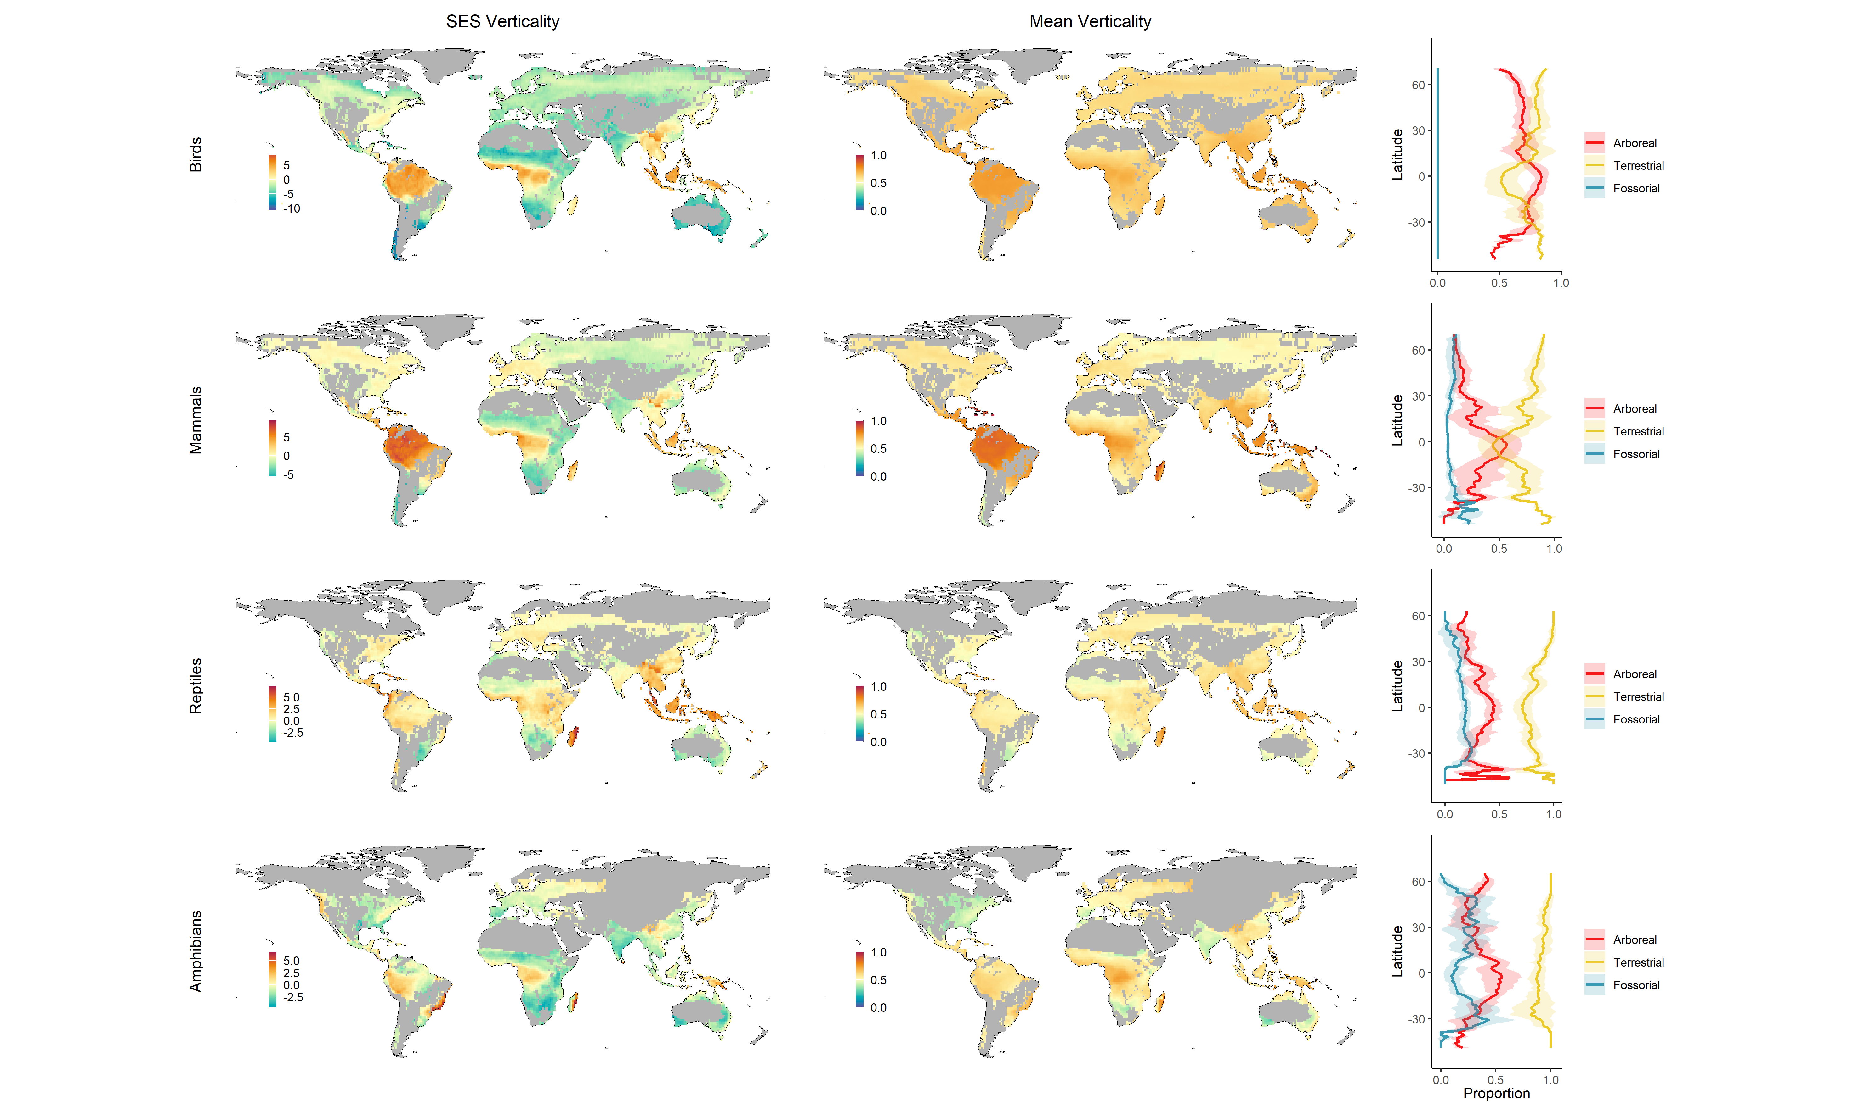

**Fig.** **:** SES and mean verticality of birds, mammals, reptiles, and amphibians. Line plots inidicate the average proportion of arboreal (red), terrestrial (yellow), and fossorial (blue) species across latitudes. Gray areas indicate areas that are not wooded or that have fewer than five species.

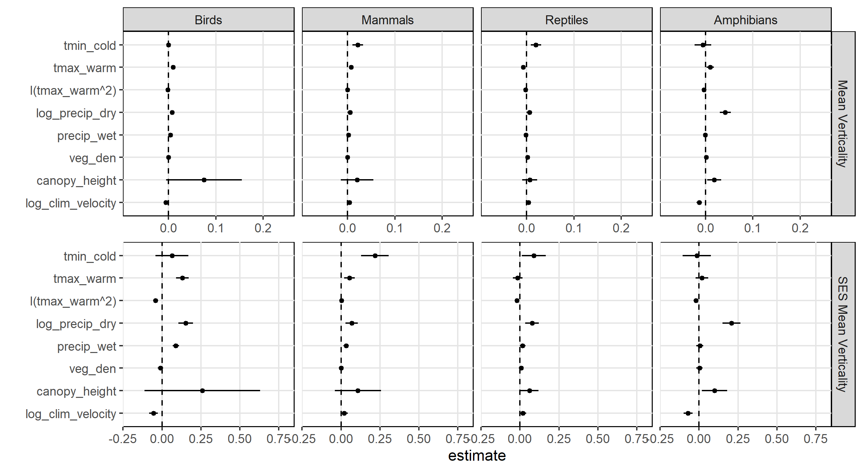

**Fig.** **:** Coefficient estimates for models of mean and SES verticality with 95% confidence intervals. tmin_cold = minimum temperature of the coldest month, tmax_warm = maximum temperature of the warmest month, precip_dry = precipitation of the driest month, precip_wet = precipitation of the wettest month, veg_den = vegetation density, clim_velocity = climate velocity

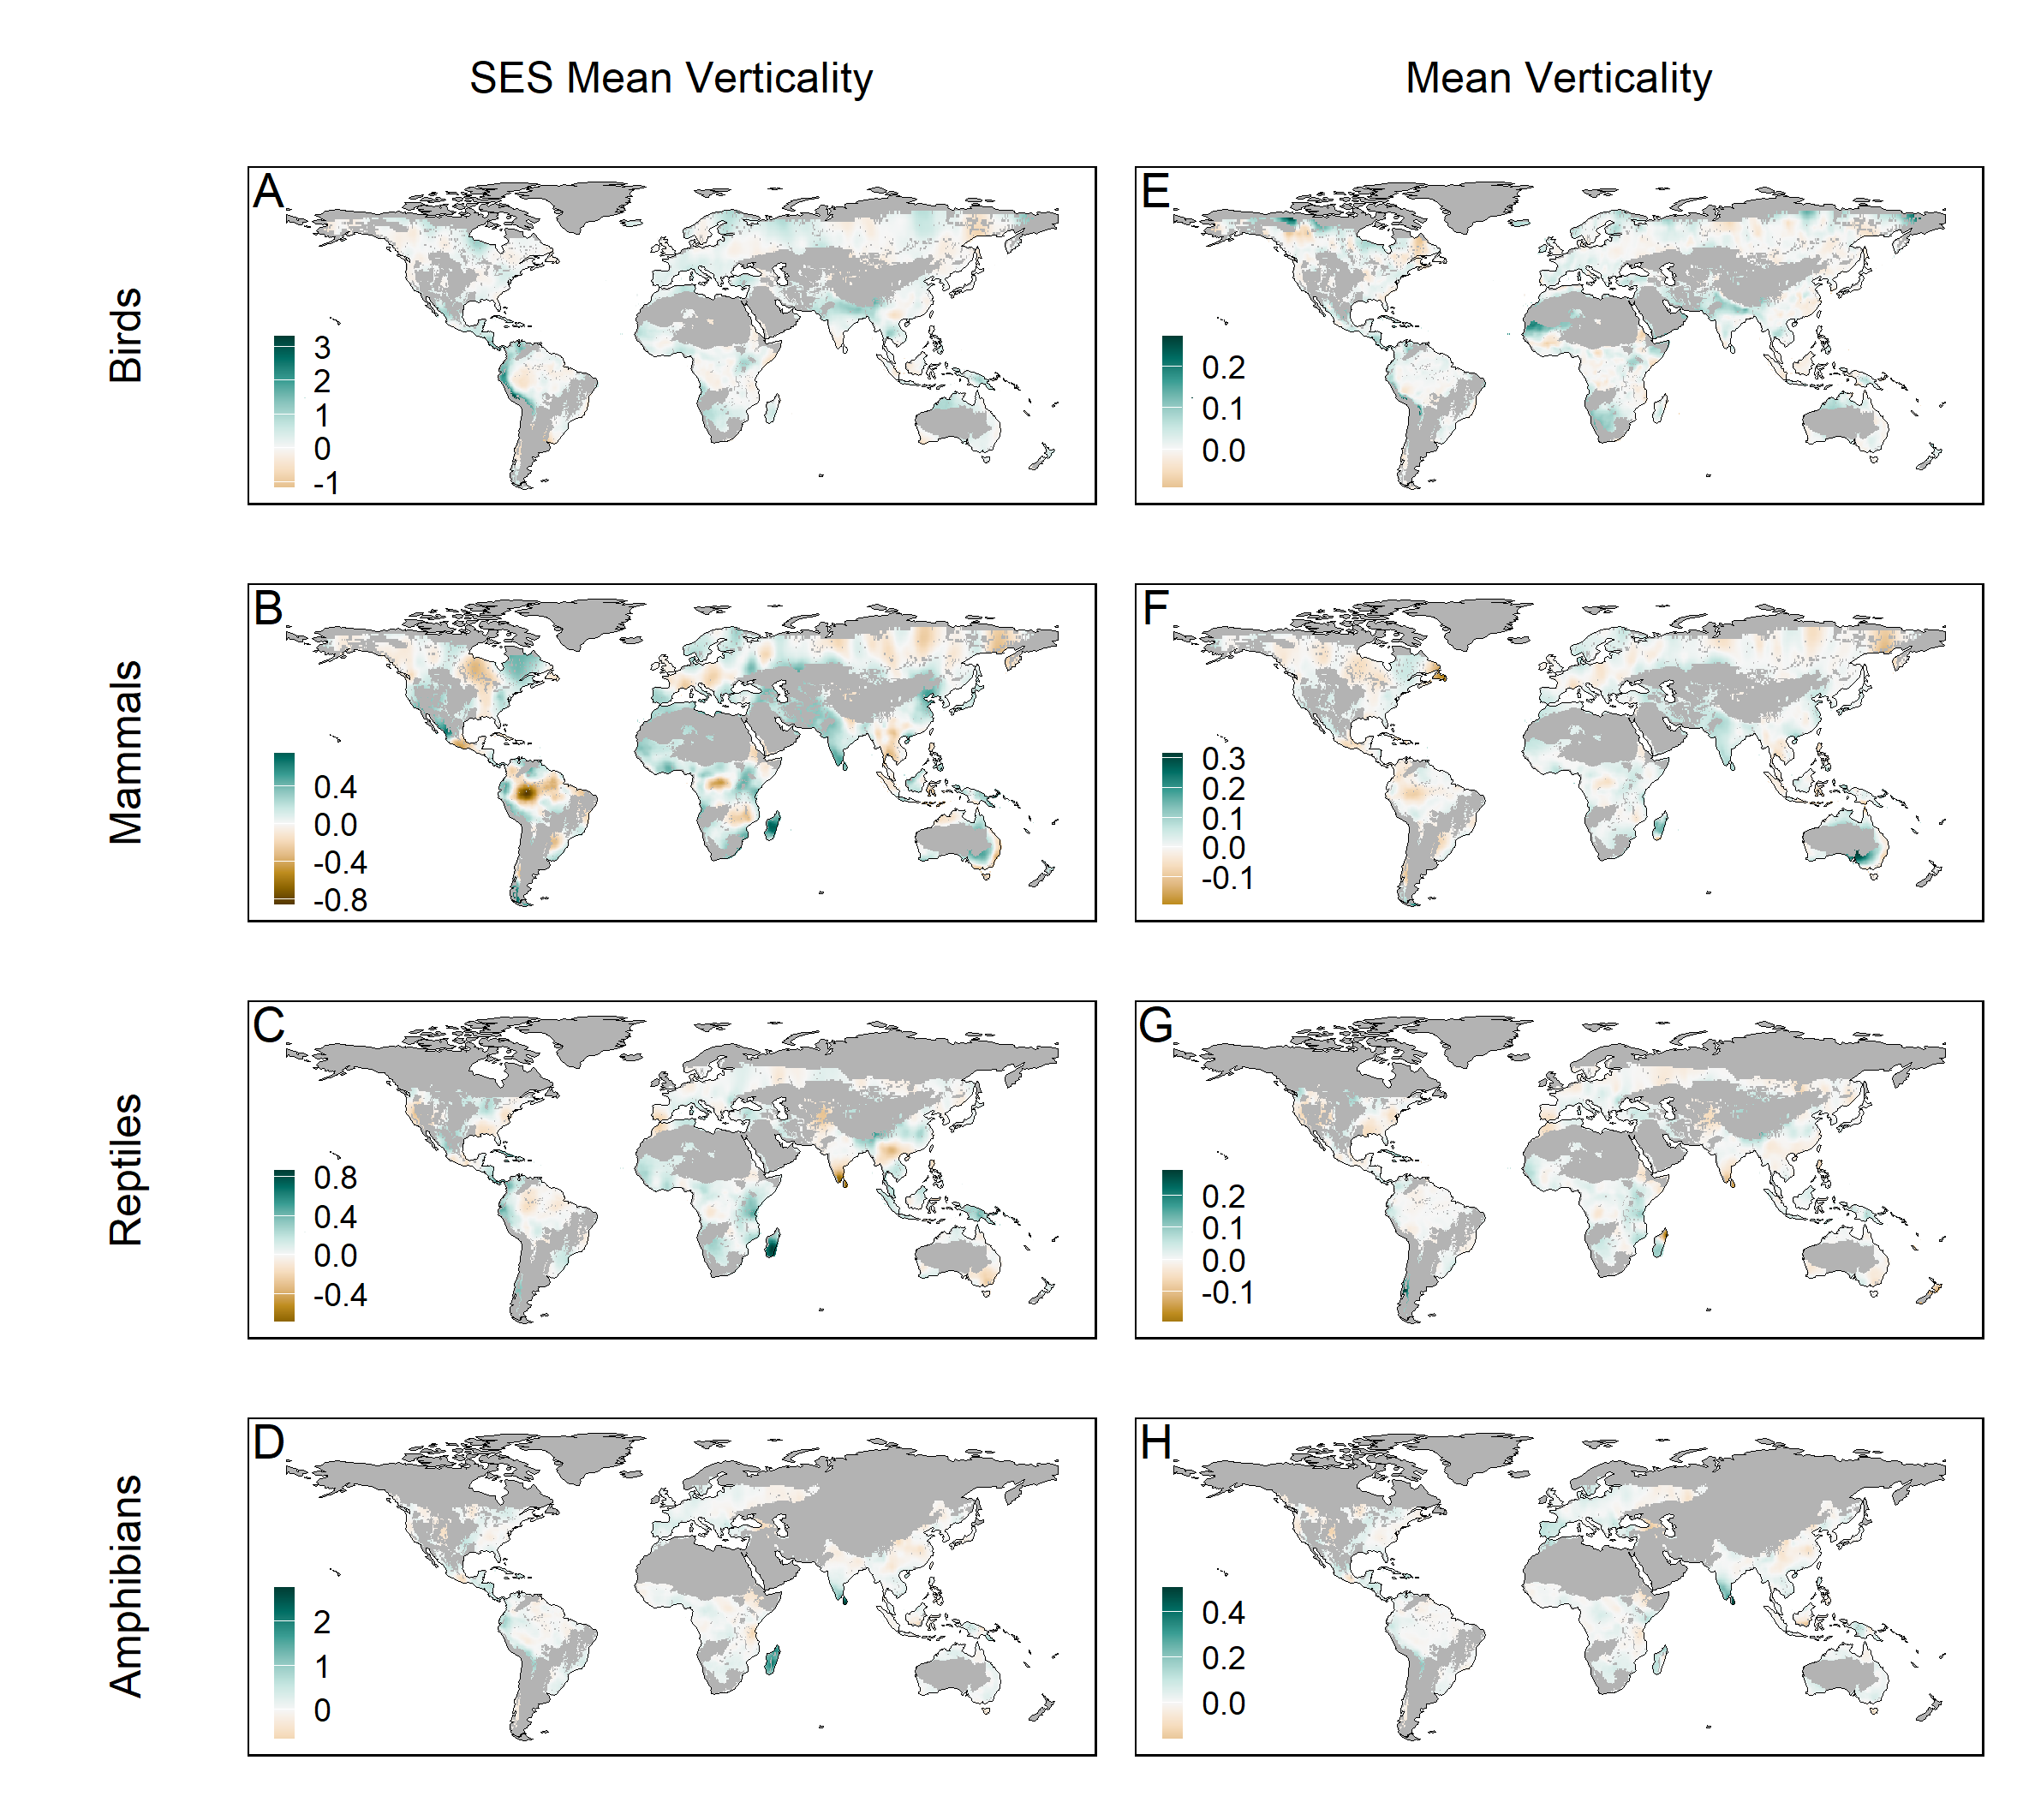

**Fig.** **:** Spatially varying coefficients for canopy height in models GLMMs of SES and mean verticality for birds, mammals, reptiles, and amphibians. Gray areas indicate areas that are not wooded or that have fewer than five species.

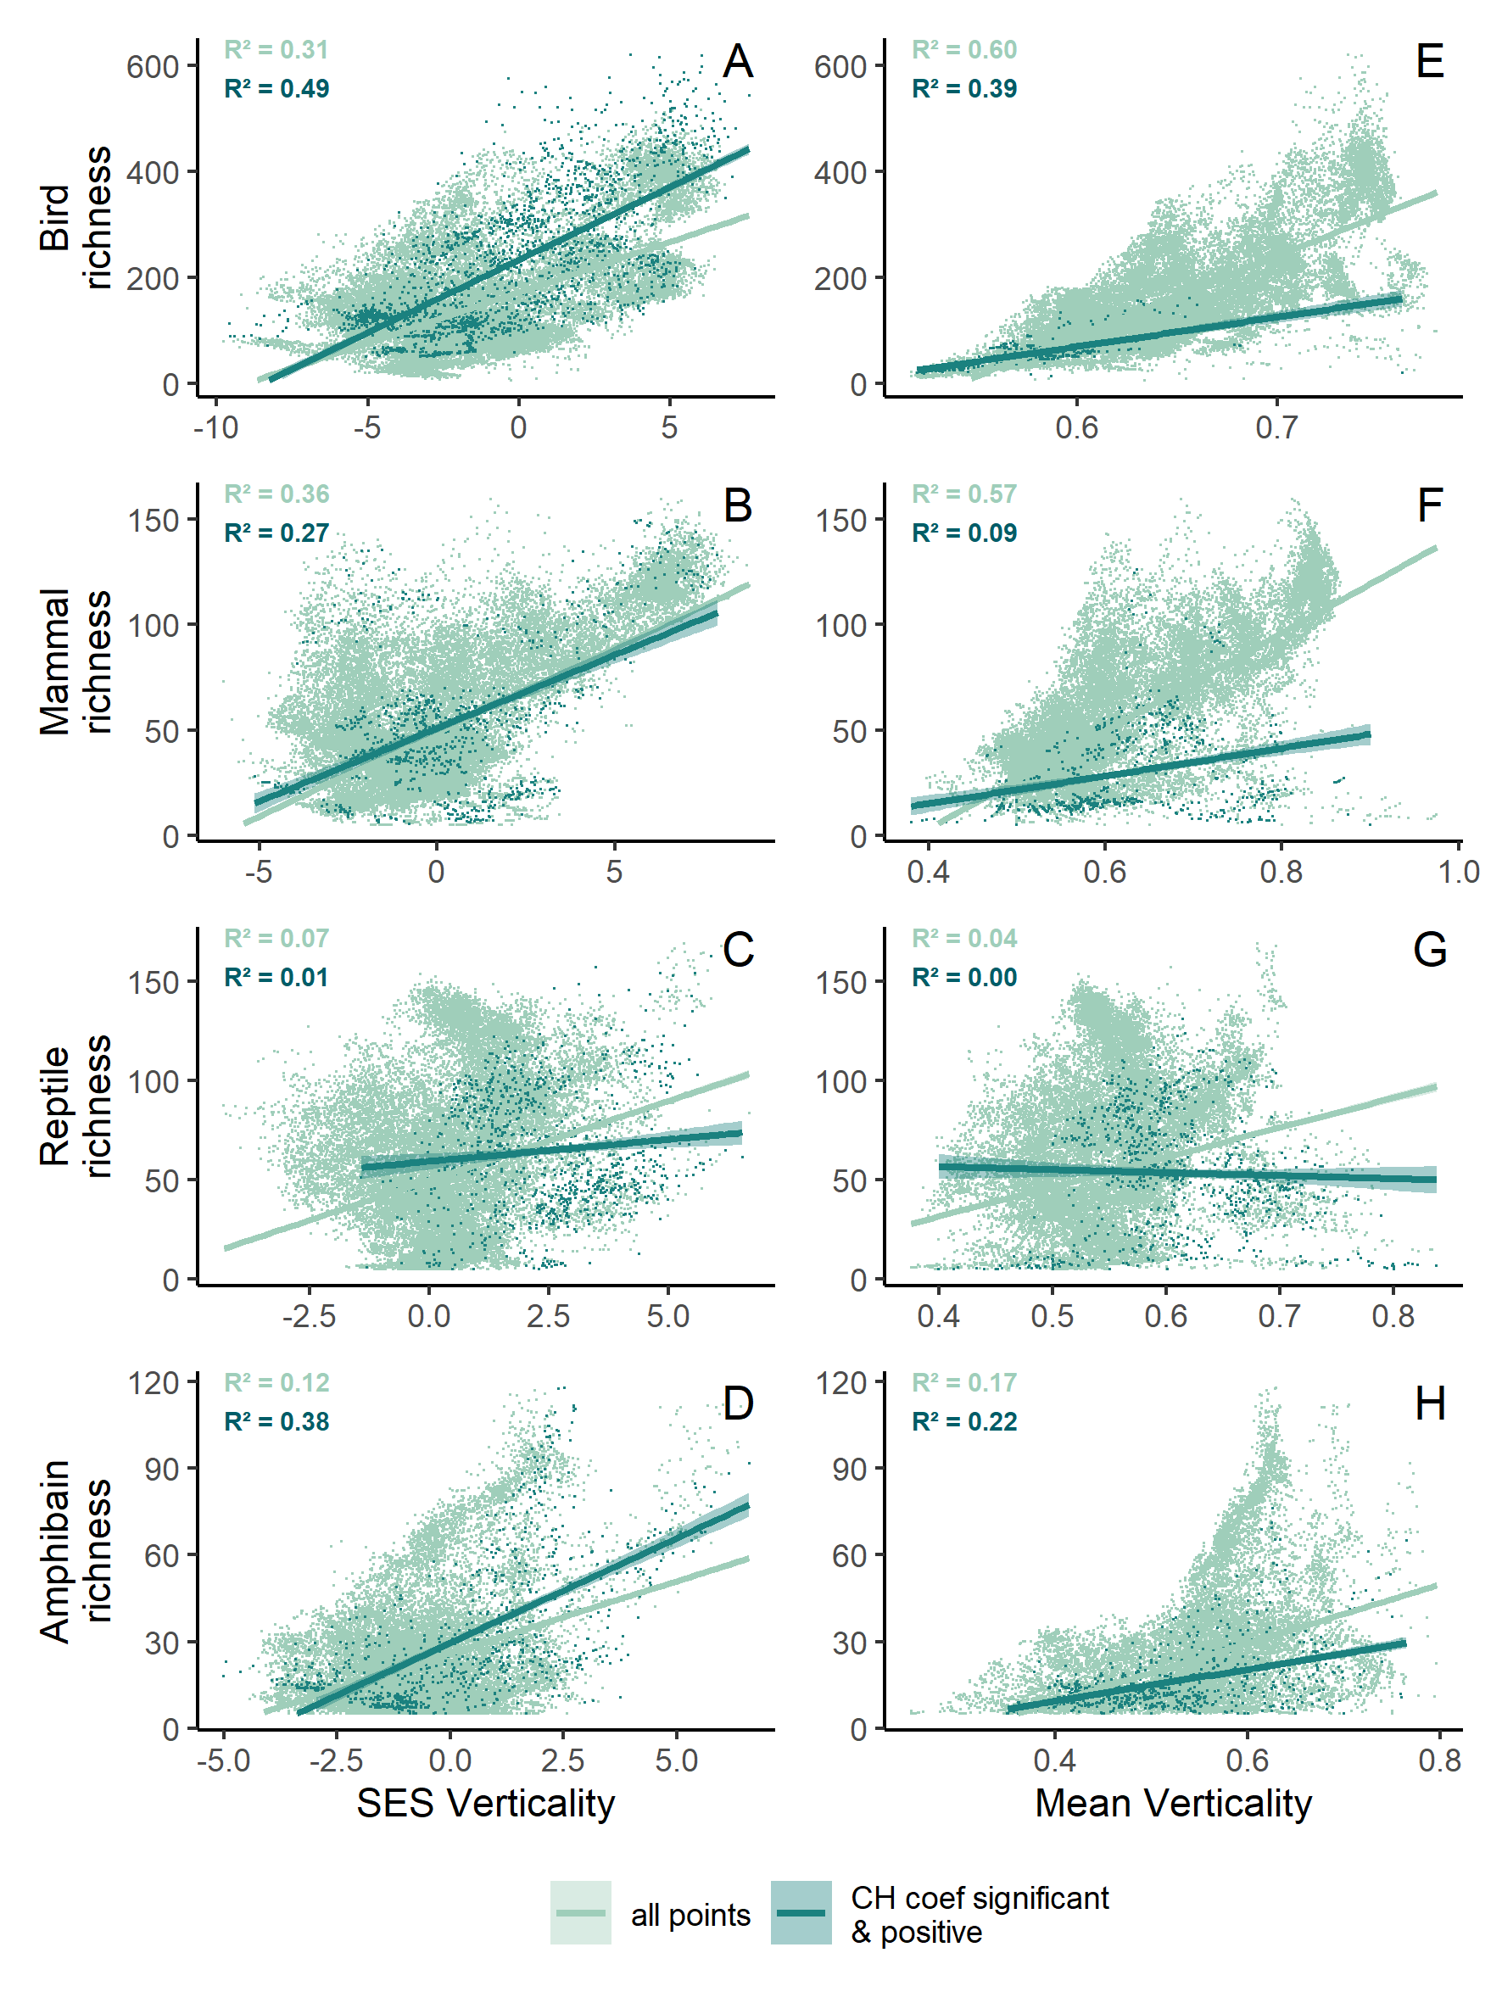

**Fig.** **:** Correlation between richness and SES verticality (A-D) or mean verticality (E-H) for all points and for points where the canopy height coefficient was significant and positive.

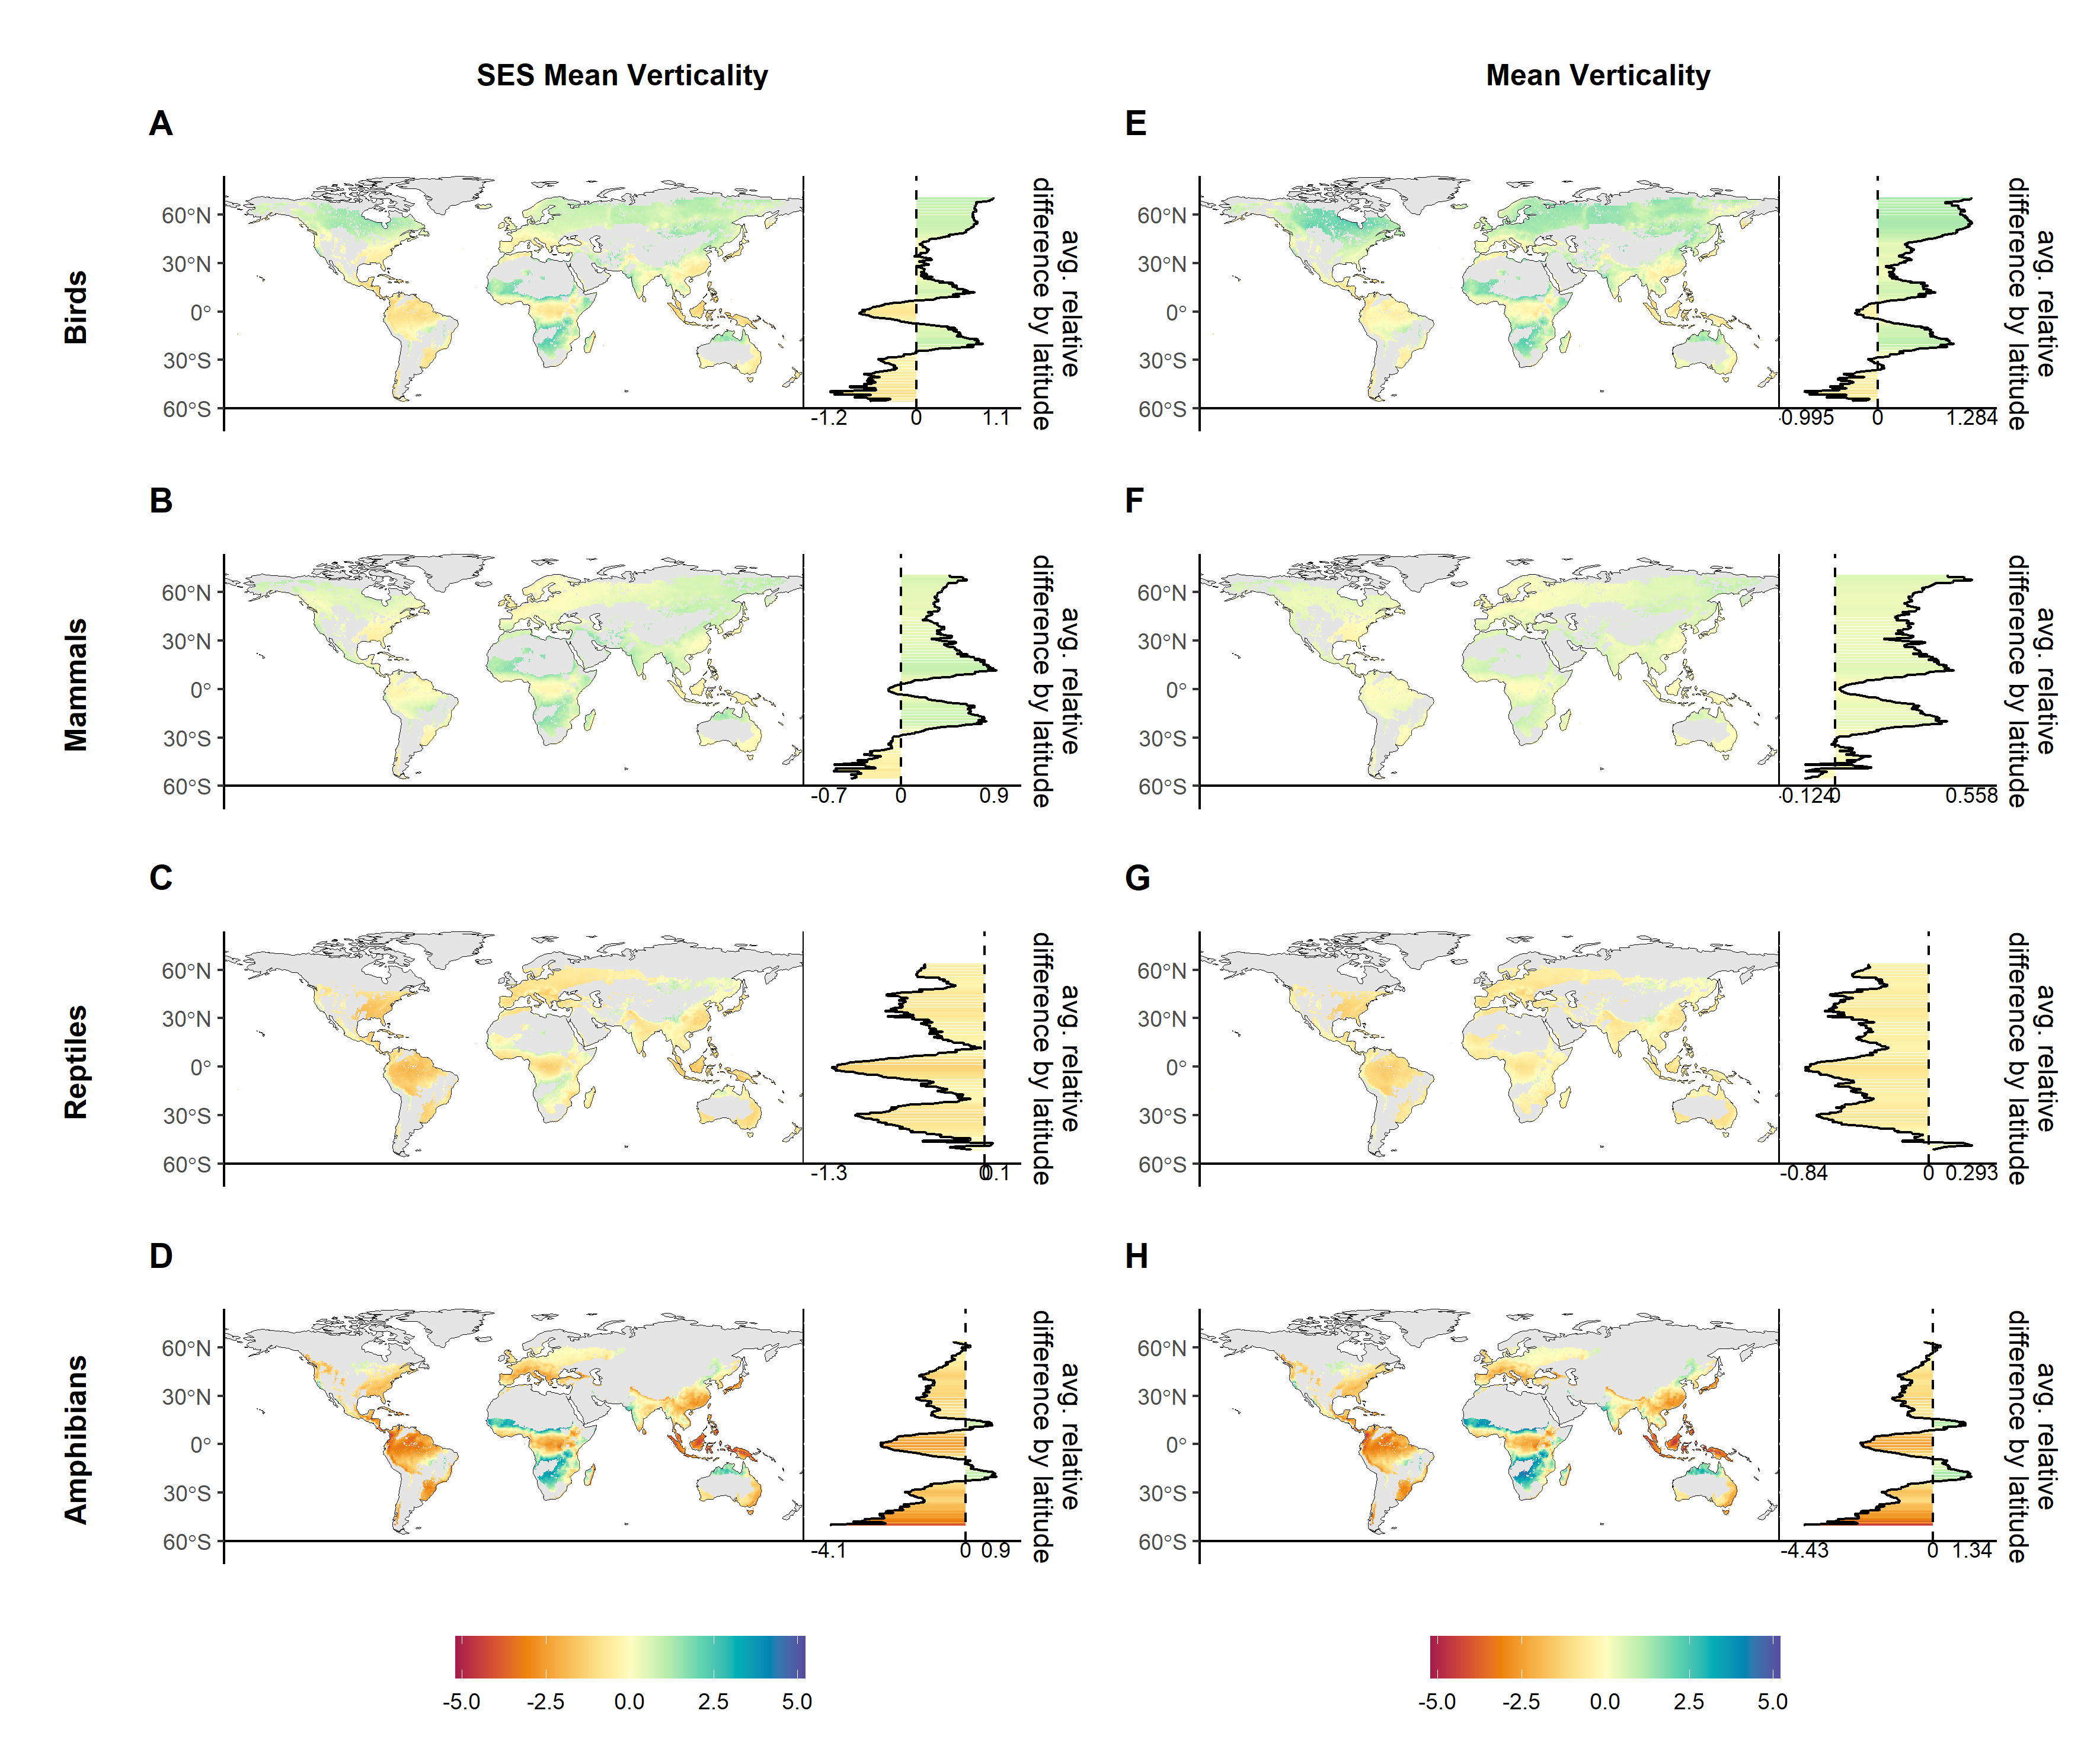

**Fig.** **:** Relative percent change in SES and mean verticality for birds, mammals, reptiles, and amphibians. Bar plots inidcate average relative percent change per latitude. Gray areas indicate areas that are not wooded or that have fewer than five species.

# Supplementary tables

*Remove NA values because gradient issue is okay Re: question posted to sdmTMB forum*

**Table** **:** Model selection criteria for models of mean and SES verticality for all four vertebrate taxa. The log-likelihood, AIC, and delta AIC are for models trained with all points. The average log-likelihood is the average sum of log-likelihood values for left out test data across five folds. NA values are caused by not meeting all model assumptions across all five cross-validation folds.

| taxon | response_var | model | logLik | df | AIC | deltaAIC | avg_logLik |
| --- | --- | --- | --- | --- | --- | --- | --- |
| Amphibians | Mean verticality | mod.realm.svc | 55,598.07 | 14 | -111,168.13 | 0.00 | 9,740.66 |
| mod.svc | 55,593.30 | 13 | -111,160.60 | 7.53 | 9,999.80 |
| mod.realm | 55,450.90 | 13 | -110,875.80 | 292.34 | 9,266.92 |
| mod | 55,445.89 | 12 | -110,867.79 | 300.35 | 9,379.83 |
| SES verticality | mod.realm.svc | -9,441.23 | 14 | 18,910.47 | 0.00 | -2,009.95 |
| mod.realm | -9,657.63 | 13 | 19,341.26 | 430.79 | -2,186.58 |
| mod.svc | -10,077.62 | 13 | 20,181.24 | 1,270.77 | -2,128.53 |
| mod | -10,303.25 | 12 | 20,630.49 | 1,720.03 | -2,324.51 |
| Birds | Mean verticality | mod.realm.svc | 121,049.01 | 14 | -242,070.01 | 0.00 | 24,626.93 |
| mod.svc | 121,031.04 | 13 | -242,036.07 | 33.94 | 24,631.04 |
| mod.realm | 119,182.46 | 13 | -238,338.91 | 3,731.10 | 24,174.92 |
| mod | 119,161.63 | 12 | -238,299.27 | 3,770.75 | 23,762.43 |
| SES verticality | mod.realm.svc | -17,476.82 | 14 | 34,981.64 | 0.00 | -3,161.17 |
| mod.realm | -18,167.23 | 13 | 36,360.46 | 1,378.82 | -3,219.85 |
| mod.svc | -22,642.16 | 13 | 45,310.32 | 10,328.68 | -4,082.38 |
| mod | -23,362.78 | 12 | 46,749.57 | 11,767.93 | -4,185.03 |
| Mammals | Mean verticality | mod.realm.svc | 94,471.53 | 14 | -188,915.07 | 0.00 |  |
| mod.svc | 94,470.49 | 13 | -188,914.98 | 0.09 | 18,924.92 |
| mod | 94,283.29 | 12 | -188,542.57 | 372.50 | 19,183.86 |
| mod.realm | 94,284.20 | 13 | -188,542.39 | 372.68 |  |
| SES verticality | mod.realm.svc | -11,364.54 | 14 | 22,757.07 | 0.00 | -1,929.09 |
| mod.realm | -11,496.88 | 13 | 23,019.75 | 262.68 | -1,849.05 |
| mod.svc | -16,952.65 | 13 | 33,931.30 | 11,174.23 | -2,888.46 |
| mod | -17,240.14 | 12 | 34,504.29 | 11,747.21 | -3,153.80 |
| Reptiles | Mean verticality | mod.realm.svc | 73,969.99 | 14 | -147,911.97 | 0.00 | 14,713.39 |
| mod.svc | 73,962.22 | 13 | -147,898.45 | 13.53 | 14,613.18 |
| mod.realm | 73,791.34 | 13 | -147,556.69 | 355.28 | 14,846.23 |
| mod | 73,786.99 | 12 | -147,549.97 | 362.00 | 14,653.10 |
| SES verticality | mod.realm.svc | -6,611.93 | 14 | 13,251.86 | 0.00 | -1,347.80 |
| mod.realm | -6,692.99 | 13 | 13,411.97 | 160.12 | -1,365.67 |
| mod.svc | -8,086.73 | 13 | 16,199.45 | 2,947.60 | -1,662.43 |
| mod | -8,181.99 | 12 | 16,387.98 | 3,136.12 | -1,653.50 |

# estimated coefficients and confidence intervals from the best model for each taxa - include all model parameters: fixed effects, spatial paramters (matern range, marginal spatial standard, deviation), distribution parameters

# Supplementary figures

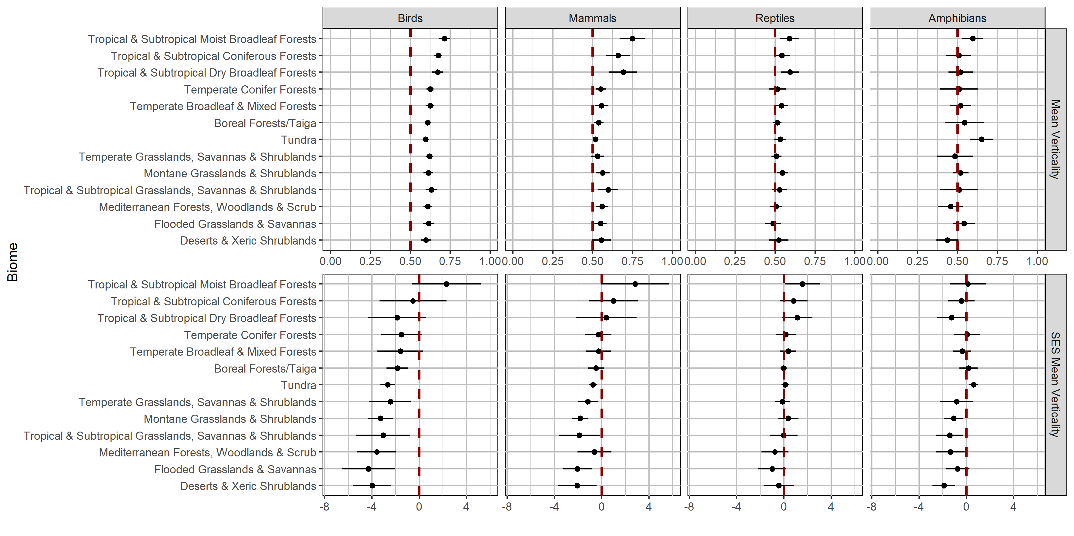

**Fig. S****:**



**Fig. S****:** Percent relative difference between SES and mean verticality predicted under present and future climate conditions for global biomes. Negative values indicate predicted declines in verticality and positive values indicate predicted increases in verticality. Biomes along the y-axis are ordered from those that were predicted to exhibit the greatest average in verticality across taxa at the top to those that were predicted to exhibit the greatest average decrease in verticality at the bottom.

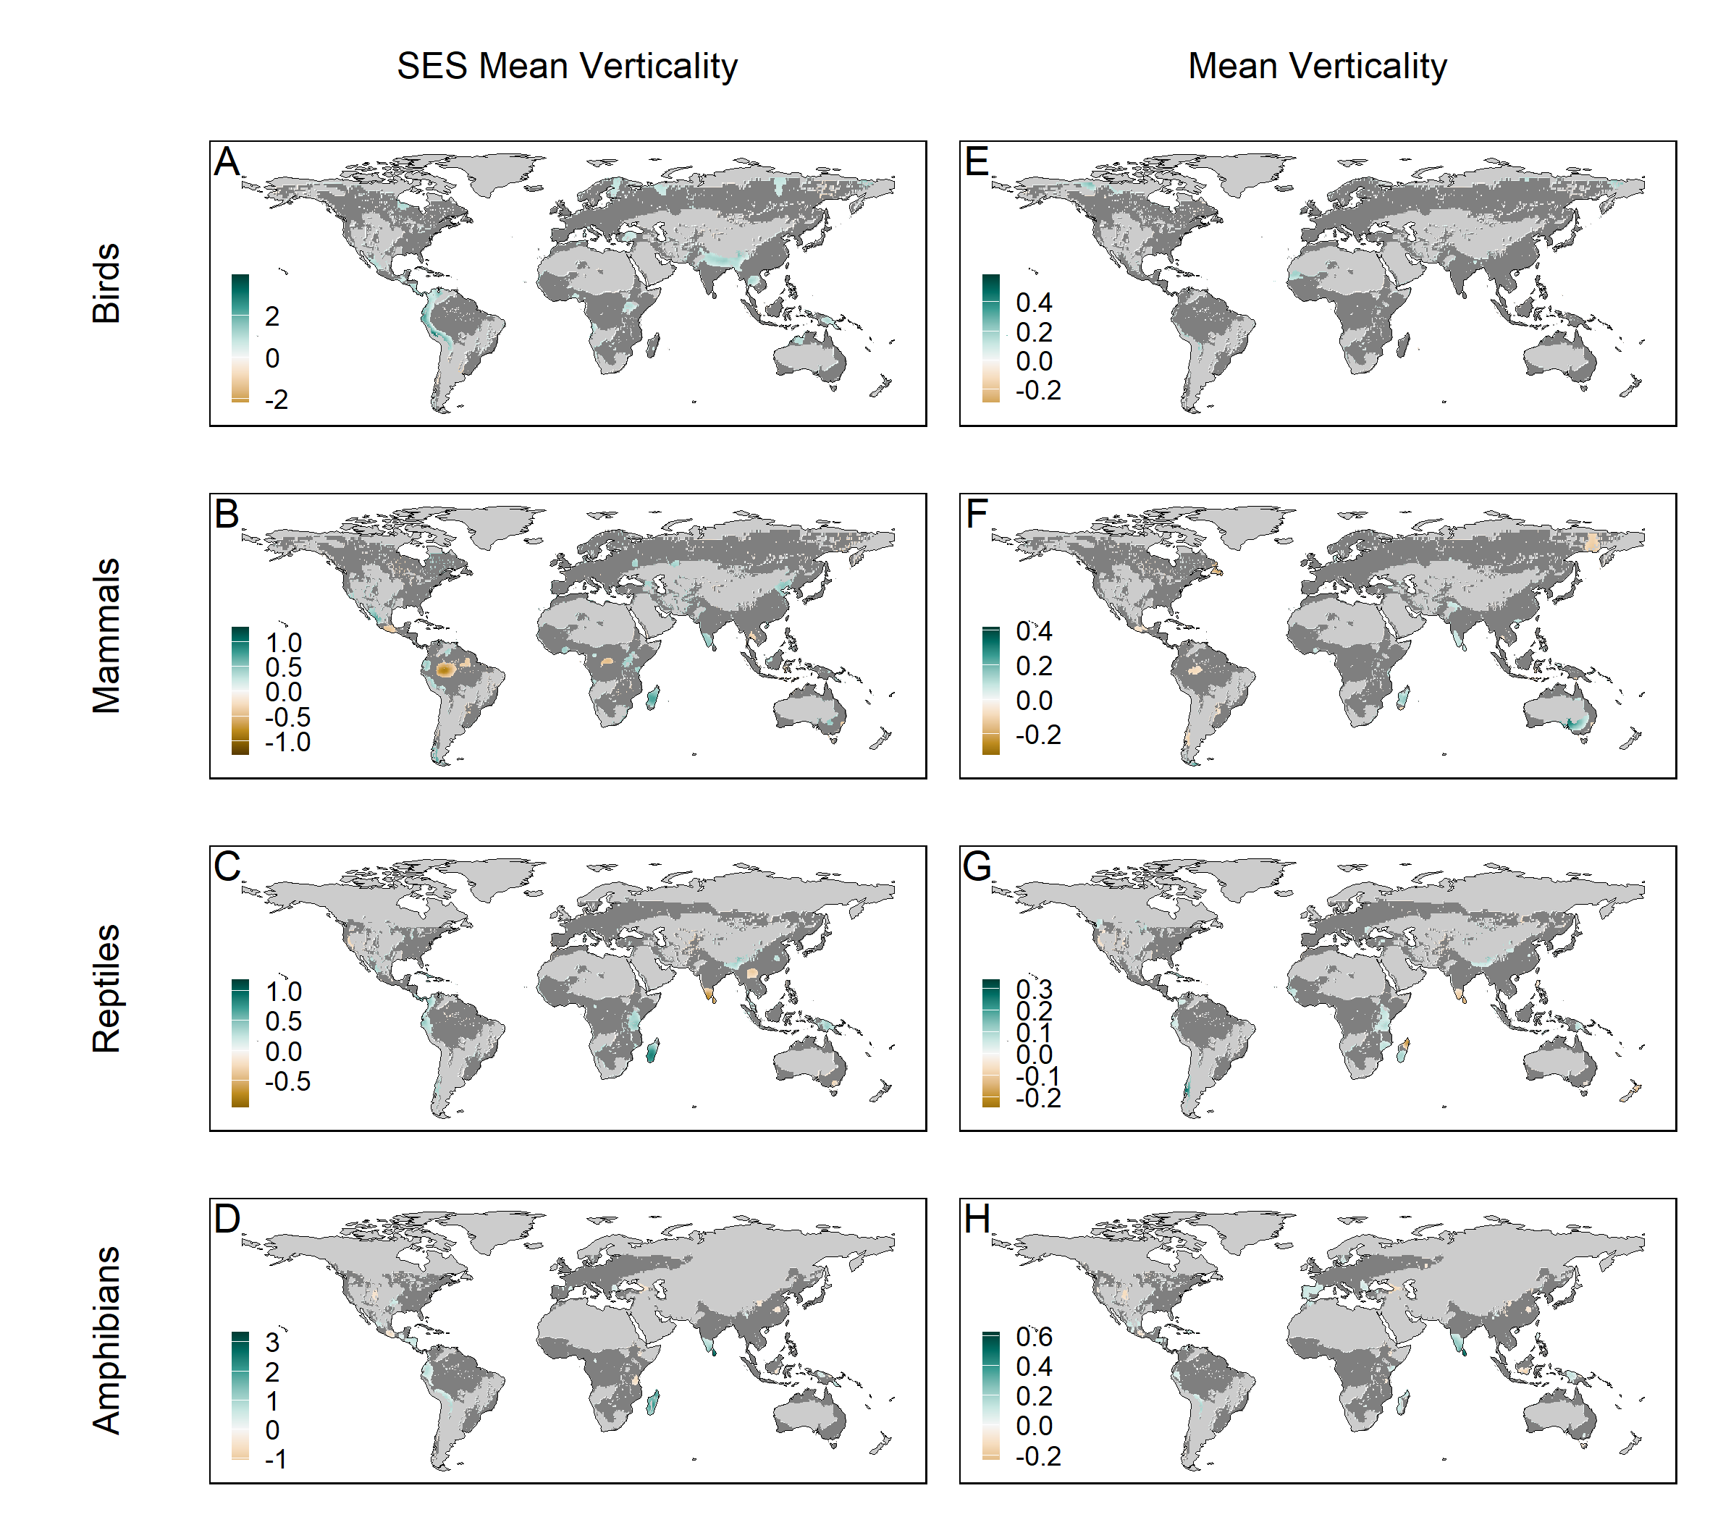

**Fig. S****:** Areas in which the spatially varying coefficient for canopy height had a significant positive or negative effect on SES or mean verticality of birds, mammals, reptiles, and amphibians.

#```{r fig.id=“vertses-hist-biome”, fig.lp=“ed”, fig.cap=“Histograms of verticality by biome for each vertebrate class. Red dotted line indicates the mean #verticality for each biome/class.”} ## plot SES vert by biome #(“figures/supp_figs/vert_biome_forestOnly_forestSES.R”) #plt_vertses_biome

#```

#```{r fig.id=“vert-forest”, fig.lp=“ed”, fig.cap=“Mean verticality, standard effect size (SES) of mean verticality, and the average proportion of species #exhibiting arboreal, terrestrial, and fossorial strategies across latitudinal bands. In maps of mean veticality, assemblages composed of only fossorial species #are zero (red) and those composed of only arboreal species are quantified as one (purple). In maps of the SES of mean verticality, negative numbers (red) #indicate assemblages have lower verticality than expected by random chance and positive numbers (purple) indicate assemblages have higher verticality than #expected by random chance. Line graphs show the average proportion of species exhibiting arboreal (blue), terrestrial (yellow), and fossorial (red) strategies. #Proportions for each assemblage can exceed one because species can exhibit multiple vertical strategies.}

#```

#```{r fig.id=“forest-model-coefs”}

#```

# References

# Acknowledgements

Alencar, Laura Rodrigues Vieira de, Marcio Martins, Gustavo Burin, and Tiago Bosisio Quental. 2017. “Arboreality Constrains Morphological Evolution but Not Species Diversification in Vipers.” *Proceedings of the Royal Society B: Biological Sciences* 284 (1869): 20171775. <https://doi.org/10.1098/rspb.2017.1775>.

Anderson, Sean C., Eric J. Ward, Philina A. English, Lewis A. K. Barnett, and James T. Thorson. 2024. “sdmTMB: An R Package for Fast, Flexible, and User-Friendly Generalized Linear Mixed Effects Models with Spatial and Spatiotemporal Random Fields.” February 5, 2024. <https://doi.org/10.1101/2022.03.24.485545>.

Baken, Erica K., Lauren E. Mellenthin, and Dean C. Adams. 2021. “Is Salamander Arboreality Limited by Broad-Scale Climatic Conditions?” *PLoS ONE* 16 (8). <https://doi.org/10.1371/journal.pone.0255393>.

Barnett, Lewis A. K., Eric J. Ward, and Sean C. Anderson. 2021. “Improving Estimates of Species Distribution Change by Incorporating Local Trends.” *Ecography* 44 (3): 427–39. <https://doi.org/10.1111/ecog.05176>.

Basham, Edmund W., J. Alex Baecher, David H. Klinges, and Brett R. Scheffers. 2023. “Vertical Stratification Patterns of Tropical Forest Vertebrates: A Meta‐analysis.” *Biological Reviews* 98 (1): 99–114. <https://doi.org/10.1111/brv.12896>.

Basham, Edmund W., and Brett R. Scheffers. 2020. “Vertical Stratification Collapses Under Seasonal Shifts in Climate.” *Journal of Biogeography* 47 (9): 1888–98. <https://doi.org/10.1111/jbi.13857>.

Birds of the World, BirdLife International and Handbook of the. 2022. “Bird Species Distribution Maps of the World. Version 2022.2.” <http://datazone.birdlife.org/species/requestsdis>.

Borderieux, Jeremy, Jean-Claude Gégout, and Josep M. Serra-Diaz. 2024. “Extinction Drives Recent Thermophilization but Does Not Trigger Homogenization in Forest Understorey.” *Nature Ecology & Evolution*, March, 1–10. <https://doi.org/10.1038/s41559-024-02362-3>.

Burns, P., C. Hakkenberg, and S. J. Goetz. 2024. “Gridded GEDI Vegetation Structure Metrics and Biomass Density at Multiple Resolutions.” ORNL DAAC, Oak Ridge, Tennessee, USA. 2024. <https://doi.org/10.3334/ORNLDAAC/2339>.

Byman, D., D. B. Hay, and G. S. Bakken. 1988. “Energetic Costs of the Winter Arboreal Microclimate: The Gray Squirrel in a Tree.” *International Journal of Biometeorology* 32 (2): 112–22. <https://doi.org/10.1007/BF01044904>.

Cabral, Hugo, Thaís B. Guedes, and Diego J. Santana. 2022. “Functional Traits and Phylogeny Explain Snake Distribution in the World’s Largest Dry Forest Ecoregion, the Gran Chaco.” *Ecology and Evolution* 12 (11): e9503. <https://doi.org/10.1002/ece3.9503>.

Caetano, Gabriel Henrique de Oliveira, David G. Chapple, Richard Grenyer, Tal Raz, Jonathan Rosenblatt, Reid Tingley, Monika Böhm, Shai Meiri, and Uri Roll. 2022. “Automated Assessment Reveals That the Extinction Risk of Reptiles Is Widely Underestimated Across Space and Phylogeny.” *PLOS Biology* 20 (5): e3001544. <https://doi.org/10.1371/journal.pbio.3001544>.

Camargo, Nícholas F., Nayara Y. Sano, Juliana F. Ribeiro, and Emerson M. Vieira. 2016. “Contrasting the Realized and Fundamental Niche of the Arboreal Walking Performance of Neotropical Rodents.” *Journal of Mammalogy* 97 (1): 155–66. <https://doi.org/10.1093/jmammal/gyv166>.

Chust, Guillem, Ernesto Villarino, Matthew McLean, Nova Mieszkowska, Lisandro Benedetti-Cecchi, Fabio Bulleri, Chiara Ravaglioli, et al. 2024. “Cross-Basin and Cross-Taxa Patterns of Marine Community Tropicalization and Deborealization in Warming European Seas.” *Nature Communications* 15 (1): 2126. <https://doi.org/10.1038/s41467-024-46526-y>.

Colwell, Robert K., and Kenneth J. Feeley. 2024. “Still Little Evidence of Poleward Range Shifts in the Tropics, but Lowland Biotic Attrition May Be Underway.” *Biotropica* n/a (n/a): e13358. <https://doi.org/10.1111/btp.13358>.

Coops, Nicholas C., Gregory J. M. Rickbeil, Douglas K. Bolton, Margaret E. Andrew, and Niels C. Brouwers. 2018. “Disentangling Vegetation and Climate as Drivers of Australian Vertebrate Richness.” *Ecography* 41 (7): 1147–60. <https://doi.org/10.1111/ecog.02813>.

Crowther, T. W., H. B. Glick, K. R. Covey, C. Bettigole, D. S. Maynard, S. M. Thomas, J. R. Smith, et al. 2015. “Mapping Tree Density at a Global Scale.” *Nature* 525 (7568): 201–5. <https://doi.org/10.1038/nature14967>.

Culbert, Patrick D., Volker C. Radeloff, Curtis H. Flather, Josef M. Kellndorfer, Chadwick D. Rittenhouse, and Anna M. Pidgeon. 2013. “The Influence of Vertical and Horizontal Habitat Structure on Nationwide Patterns of Avian Biodiversity.” *The Auk* 130 (4): 656–65. <https://doi.org/10.1525/auk.2013.13007>.

Cyriac, V. P., and U. Kodandaramaiah. 2018. “Digging Their Own Macroevolutionary Grave: Fossoriality as an Evolutionary Dead End in Snakes.” *Journal of Evolutionary Biology* 31 (4): 587–98. <https://doi.org/10.1111/jeb.13248>.

De Frenne, Pieter, Florian Zellweger, Francisco Rodríguez-Sánchez, Brett R. Scheffers, Kristoffer Hylander, Miska Luoto, Mark Vellend, Kris Verheyen, and Jonathan Lenoir. 2019. “Global Buffering of Temperatures Under Forest Canopies.” *Nature Ecology & Evolution* 3 (5): 744–49. <https://doi.org/10.1038/s41559-019-0842-1>.

Delgado-Martínez, Carlos M., Melanie Kolb, Fermín Pascual-Ramírez, and Eduardo Mendoza. 2023. “Differential Utilization of Surface and Arboreal Water Bodies by Birds and Mammals in a Seasonally Dry Neotropical Forest in Southern Mexico.” *Ecology and Evolution* 13 (11): e10781. <https://doi.org/10.1002/ece3.10781>.

Dinerstein, Eric, David Olson, Anup Joshi, Carly Vynne, Neil D. Burgess, Eric Wikramanayake, Nathan Hahn, et al. 2017. “An Ecoregion-Based Approach to Protecting Half the Terrestrial Realm.” *BioScience* 67 (6): 534–45. <https://doi.org/10.1093/biosci/bix014>.

Doser, Jeffrey W., Marc Kéry, Sarah P. Saunders, Andrew O. Finley, Brooke L. Bateman, Joanna Grand, Shannon Reault, Aaron S. Weed, and Elise F. Zipkin. 2024. “Guidelines for the Use of Spatially Varying Coefficients in Species Distribution Models.” *Global Ecology and Biogeography* 33 (4): e13814. <https://doi.org/10.1111/geb.13814>.

Eppley, Timothy M., Selwyn Hoeks, Colin A. Chapman, Jörg U. Ganzhorn, Katie Hall, Megan A. Owen, Dara B. Adams, et al. 2022. “Factors Influencing Terrestriality in Primates of the Americas and Madagascar.” *Proceedings of the National Academy of Sciences* 119 (42): e2121105119. <https://doi.org/10.1073/pnas.2121105119>.

Feeley, K. J., C. Bravo-Avila, B. Fadrique, T. M. Perez, and D. Zuleta. 2020. “Climate-Driven Changes in the Composition of New World Plant Communities.” *Nature Climate Change* 10 (10): 965–70. <https://doi.org/10.1038/s41558-020-0873-2>.

Feng, Gang, Jian Zhang, Marco Girardello, Vincent Pellissier, and Jens-Christian Svenning. 2020. “Forest Canopy Height Co-Determines Taxonomic and Functional Richness, but Not Functional Dispersion of Mammals and Birds Globally.” *Global Ecology and Biogeography* 29 (8): 1350–59. <https://doi.org/10.1111/geb.13110>.

Gillespie, Thomas W., and Hartmut Walter. 2001. “Distribution of Bird Species Richness at a Regional Scale in Tropical Dry Forest of Central America.” *Journal of Biogeography* 28 (5): 651–62. <https://doi.org/10.1046/j.1365-2699.2001.00575.x>.

Hartig, Florian. 2022. “DHARMa: Residual Diagnostics for Hierarchical (Multi-Level / Mixed) Regression Model. R Package Version 0.4.6.” <https://CRAN.R-project.org/package=DHARMa>.

IPCC. 2023. “Climate Change 2023: Synthesis Report. Contribution of Working Groups I, II and III to the Sixth Assessment Report of the Intergovernmental Panel on Climate Change [Core Writing Team, H. Lee and J. Romero (Eds.)].” First. Geneva, Switzerland: IPCC. <https://doi.org/10.59327/IPCC/AR6-9789291691647>.

IUCN. 2023. “The IUCN Red List of Threatened Species. Version 6.3.” <https://www.iucnredlist.org>.

Karger, Dirk Nikolaus, Olaf Conrad, Jürgen Böhner, Tobias Kawohl, Holger Kreft, Rodrigo Wilber Soria-Auza, Niklaus E. Zimmermann, H. Peter Linder, and Michael Kessler. 2017. “Climatologies at High Resolution for the Earth’s Land Surface Areas.” *Scientific Data* 4 (1): 170122. <https://doi.org/10.1038/sdata.2017.122>.

———. 2021. “Data from: Climatologies at High Resolution for the Earth’s Land Surface Areas.” *EnviDat*, 2.1 KB. https://doi.org/<http://dx.doi.org/doi:10.16904/envidat.228.v2.1>.

Krainski, ET, Virgilio Gomez-Rubio, Haakon Bakka, Amanda Lenzi, Daniela Castro-Camilo, Daniel Simpson, Finn Lindgren, and Havard Rue. 2019. *Advanced Spatial Modeling with Stochastic Partial Differential Equations Using R and INLA*. Boca Raton, Florida: Chapman and Hall/CRC Press. <https://becarioprecario.bitbucket.io/spde-gitbook/index.html#>.

Lajeunesse, Armelle, and Yoan Fourcade. 2023. “Temporal Analysis of GBIF Data Reveals the Restructuring of Communities Following Climate Change.” *Journal of Animal Ecology* 92 (2): 391–402. <https://doi.org/10.1111/1365-2656.13854>.

Lang, Nico, Walter Jetz, Konrad Schindler, and Jan Dirk Wegner. 2023. “A High-Resolution Canopy Height Model of the Earth.” *Nature Ecology & Evolution* 7 (11): 1778–89. <https://doi.org/10.1038/s41559-023-02206-6>.

LaRue, Elizabeth A., Anna G. Downing, Sheila Saucedo, Arturo Rocha, Sergio A. Vargas Zesati, Vicente Mata-Silva, and Michael G. Harvey. 2023. “Diversity – Volume Relationships: Adding Structural Arrangement and Volume to Species – Area Relationships Across Forest Macrosystems.” *Ecography* 2023 (10): e06723. <https://doi.org/10.1111/ecog.06723>.

Laughlin, Andrew J, and Lars Y Pomara. 2023. “Winter Range Shifts and Their Associations with Species Traits Are Heterogeneous in Eastern North American Birds.” *Ornithology* 140 (4): ukad027. <https://doi.org/10.1093/ornithology/ukad027>.

Leahy, Lily, Brett R. Scheffers, Alan N. Andersen, Ben T. Hirsch, and Stephen E. Williams. 2021. “Vertical Niche and Elevation Range Size in Tropical Ants: Implications for Climate Resilience.” *Diversity and Distributions* 27 (3): 485–96. <https://doi.org/10.1111/ddi.13210>.

Li, Peng, and John J. Wiens. 2022. “What Drives Diversification? Range Expansion Tops Climate, Life History, Habitat and Size in Lizards and Snakes.” *Journal of Biogeography* 49 (2): 237–47. <https://doi.org/10.1111/jbi.14304>.

Lindenmayer, D. B., W. Blanchard, D. Blair, L. McBurney, C. Taylor, B. C. Scheele, M. J. Westgate, N. Robinson, and C. Foster. 2021. “The Response of Arboreal Marsupials to Long-Term Changes in Forest Disturbance.” *Animal Conservation* 24 (2): 246–58. <https://doi.org/10.1111/acv.12634>.

Lindgren, Finn, and Håvard Rue. 2015. “Bayesian Spatial Modelling with R-INLA.” *Journal of Statistical Software* 63 (February): 1–25. <https://doi.org/10.18637/jss.v063.i19>.

Lindgren, Finn, Håvard Rue, and Johan Lindström. 2011. “An Explicit Link Between Gaussian Fields and Gaussian Markov Random Fields: The Stochastic Partial Differential Equation Approach.” *Journal of the Royal Statistical Society: Series B (Statistical Methodology)* 73 (4): 423–98. <https://doi.org/10.1111/j.1467-9868.2011.00777.x>.

MacArthur, Robert H. 1958. “Population Ecology of Some Warblers of Northeastern Coniferous Forests.” *Ecology* 39 (4): 599–619. <https://doi.org/10.2307/1931600>.

Macarthur, Robert H. 1965. “Patterns of Species Diversity.” *Biological Reviews* 40 (4): 510–33. <https://doi.org/10.1111/j.1469-185X.1965.tb00815.x>.

MacArthur, Robert H., and John W. MacArthur. 1961. “On Bird Species Diversity.” *Ecology* 42 (3): 594–98. <https://doi.org/10.2307/1932254>.

Macarthur, Robert, and Richard Levins. 1967. “The Limiting Similarity, Convergence, and Divergence of Coexisting Species.” *The American Naturalist* 101 (921): 377–85. <https://www.jstor.org/stable/2459090>.

Martins, Paulo Mateus, Marti J. Anderson, Winston L. Sweatman, and Andrew J. Punnett. 2024. “Significant Shifts in Latitudinal Optima of North American Birds.” *Proceedings of the National Academy of Sciences* 121 (15): e2307525121. <https://doi.org/10.1073/pnas.2307525121>.

Moen, Daniel S., and John J. Wiens. 2017. “Microhabitat and Climatic Niche Change Explain Patterns of Diversification Among Frog Families.” *The American Naturalist* 190 (1): 29–44. <https://doi.org/10.1086/692065>.

Moura, Mario R., Karoline Ceron, Jhonny J. M. Guedes, Rosana Chen-Zhao, Yanina V. Sica, Julie Hart, Wendy Dorman, et al. 2024. “A Phylogeny-Informed Characterisation of Global Tetrapod Traits Addresses Data Gaps and Biases.” 2024. <https://doi.org/10.1101/2023.03.04.531098>.

Murray, Alexander H., A. Justin Nowakowski, and Luke O. Frishkoff. 2021. “Climate and Land‐use Change Severity Alter Trait‐based Responses to Habitat Conversion.” Edited by Adam Algar. *Global Ecology and Biogeography* 30 (3): 598–610. <https://doi.org/10.1111/geb.13237>.

Oliveira, Brunno F., and Brett R. Scheffers. 2019. “Vertical Stratification Influences Global Patterns of Biodiversity.” *Ecography* 42 (2): 249–58. <https://doi.org/10.1111/ecog.03636>.

Pellissier, Vincent, Jean-Yves Barnagaud, W. Daniel Kissling, Çağan Şekercioğlu, and Jens-Christian Svenning. 2018. “Niche Packing and Expansion Account for Species Richness–Productivity Relationships in Global Bird Assemblages.” *Global Ecology and Biogeography* 27 (5): 604–15. <https://doi.org/10.1111/geb.12723>.

Petrovan, Silviu O., Nida Al-Fulaij, Alec Christie, and Henry Andrews. 2022. “Why Link Diverse Citizen Science Surveys? Widespread Arboreal Habits of a Terrestrial Amphibian Revealed by Mammalian Tree Surveys in Britain.” *PLOS ONE* 17 (7): e0265156. <https://doi.org/10.1371/journal.pone.0265156>.

Pigot, Alex L., Christopher H. Trisos, and Joseph A. Tobias. 2016. “Functional Traits Reveal the Expansion and Packing of Ecological Niche Space Underlying an Elevational Diversity Gradient in Passerine Birds.” *Proceedings of the Royal Society B: Biological Sciences* 283 (1822): 20152013. <https://doi.org/10.1098/rspb.2015.2013>.

Roll, Uri, Anat Feldman, Maria Novosolov, Allen Allison, Aaron M. Bauer, Rodolphe Bernard, Monika Böhm, et al. 2017. “The Global Distribution of Tetrapods Reveals a Need for Targeted Reptile Conservation.” *Nature Ecology & Evolution* 1 (11): 1677–82. <https://doi.org/10.1038/s41559-017-0332-2>.

Roll, Uri, Eli Geffen, and Yoram Yom-Tov. 2015. “Linking Vertebrate Species Richness to Tree Canopy Height on a Global Scale.” *Global Ecology and Biogeography* 24 (7): 814–25. <https://doi.org/10.1111/geb.12325>.

Sandel, B., L. Arge, B. Dalsgaard, R. G. Davies, K. J. Gaston, W. J. Sutherland, and J.-C. Svenning. 2011. “The Influence of Late Quaternary Climate-Change Velocity on Species Endemism.” *Science* 334 (6056): 660–64. <https://doi.org/10.1126/science.1210173>.

Scheffers, Brett R, Ben L. Phillips, William F. Laurance, Navjot S. Sodhi, Arvin Diesmos, and Stephen E. Williams. 2013. “Increasing Arboreality with Altitude: A Novel Biogeographic Dimension.” *Proceedings of the Royal Society B: Biological Sciences* 280 (November): 20131581. <https://doi.org/10.1098/rspb.2013.1581>.

Scheffers, Brett R, and Stephen E Williams. 2018. “Tropical Mountain Passes Are Out of Reach – but Not for Arboreal Species.” *Frontiers in Ecology and the Environment* 16 (2): 101–8. <https://doi.org/10.1002/fee.1764>.

Sunday, Jennifer M., Amanda E. Bates, Michael R. Kearney, Robert K. Colwell, Nicholas K. Dulvy, John T. Longino, and Raymond B. Huey. 2014. “Thermal-Safety Margins and the Necessity of Thermoregulatory Behavior Across Latitude and Elevation.” *Proceedings of the National Academy of Sciences* 111 (15): 5610–15. <https://doi.org/10.1073/pnas.1316145111>.

Thorson, James, and Kasper Kristensen. 2024. *Spatio-Temporal Models for Ecologists*. 1st ed. Boca Raton: Chapman and Hall/CRC. <https://doi.org/10.1201/9781003410294>.

Tracy, Christopher R., Keith A. Christian, and C. Richard Tracy. 2010. “Not Just Small, Wet, and Cold: Effects of Body Size and Skin Resistance on Thermoregulation and Arboreality of Frogs.” *Ecology* 91 (5): 1477–84. <https://doi.org/10.1890/09-0839.1>.

Verschuyl, Jacob P., Andrew J. Hansen, David B. McWethy, Rex Sallabanks, and Richard L. Hutto. 2008. “Is the Effect of Forest Structure on Bird Diversity Modified by Forest Productivity.” *Ecological Applications* 18 (5): 1155–70. <https://doi.org/10.1890/07-0839.1>.

Wagner, Benjamin, Holger Kreft, Craig R. Nitschke, and Julian Schrader. 2023. “Remotely Sensed Tree Height and Density Explain Global Gliding Vertebrate Richness.” *Ecography* 2023 (12): e06435. <https://doi.org/10.1111/ecog.06435>.

Warton, David I. 2022. *Eco-Stats: Data Analysis in Ecology: From t-Tests to Multivariate Abundances*. Methods in Statistical Ecology. Cham, Switzerland: Springer. <https://doi.org/10.1007/978-3-030-88443-7>.

Wilman, Hamish, Jonathan Belmaker, Jennifer Simpson, Carolina de la Rosa, Marcelo M. Rivadeneira, and Walter Jetz. 2014. “EltonTraits 1.0: Species-level Foraging Attributes of the World’s Birds and Mammals.” *Ecology* 95 (7): 2027–27. <https://doi.org/10.1890/13-1917.1>.

Xing, Shuang, Lily Leahy, Louise A. Ashton, Roger L. Kitching, Timothy C. Bonebrake, and Brett R. Scheffers. 2023. “Ecological Patterns and Processes in the Vertical Dimension of Terrestrial Ecosystems.” *Journal of Animal Ecology* 92 (3): 538–51. <https://doi.org/10.1111/1365-2656.13881>.

Zuur, Alain F., ed. 2009. *Mixed Effects Models and Extensions in Ecology with R*. Statistics for Biology and Health. New York, NY: Springer.